**SNOWFLAKE**

**Step 1:** Creating the necessary Snowflake objects including database, schema, tables, and data warehouse. The weather database is created from data extracted from Snowflake marketplace.

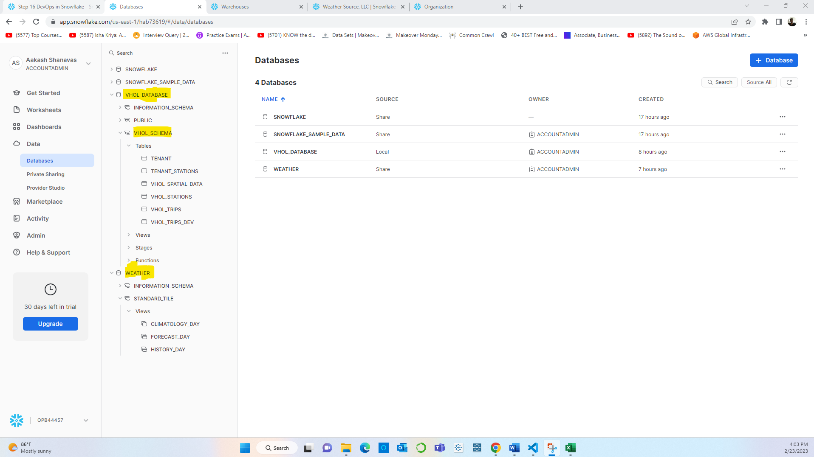

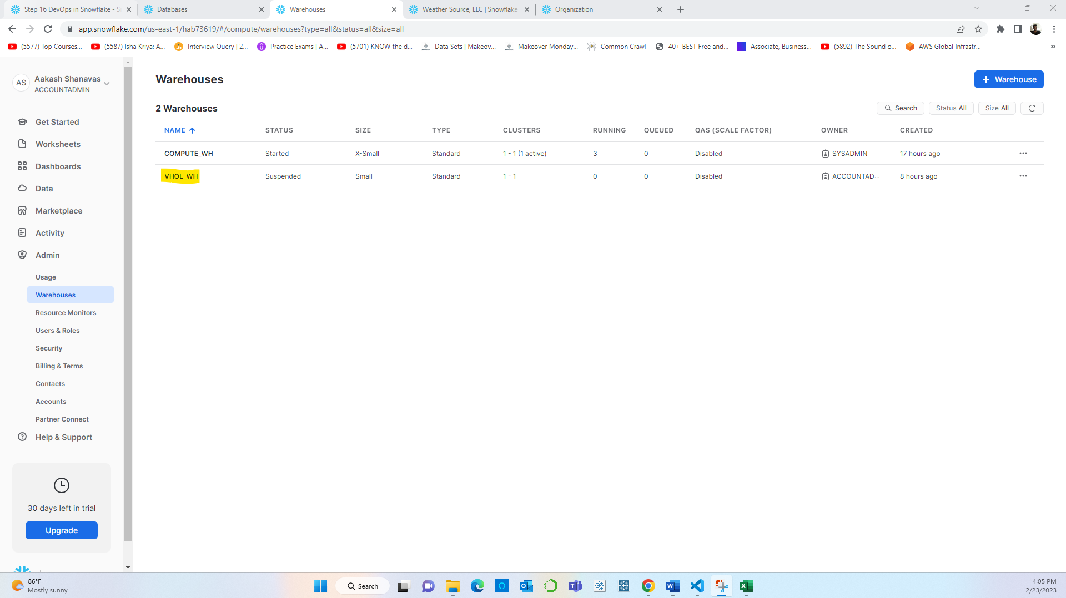

**Step 2:** SQL scripts for creating all the objects.

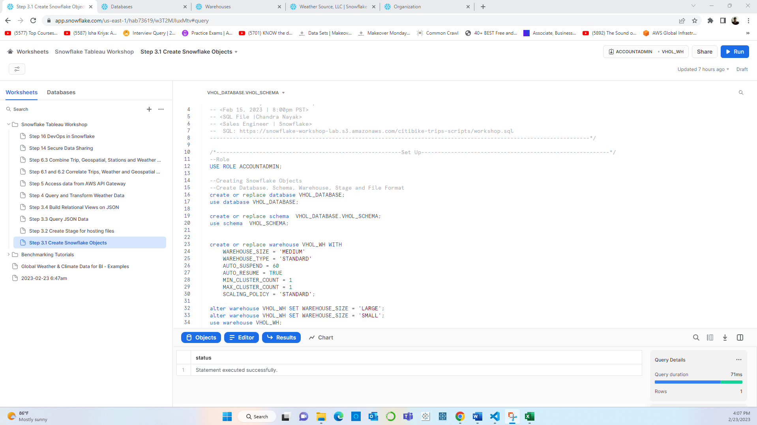

**Step 3:** Creating Staging area and updating it with city bike trips data extracted from AWS S3 Bucket.

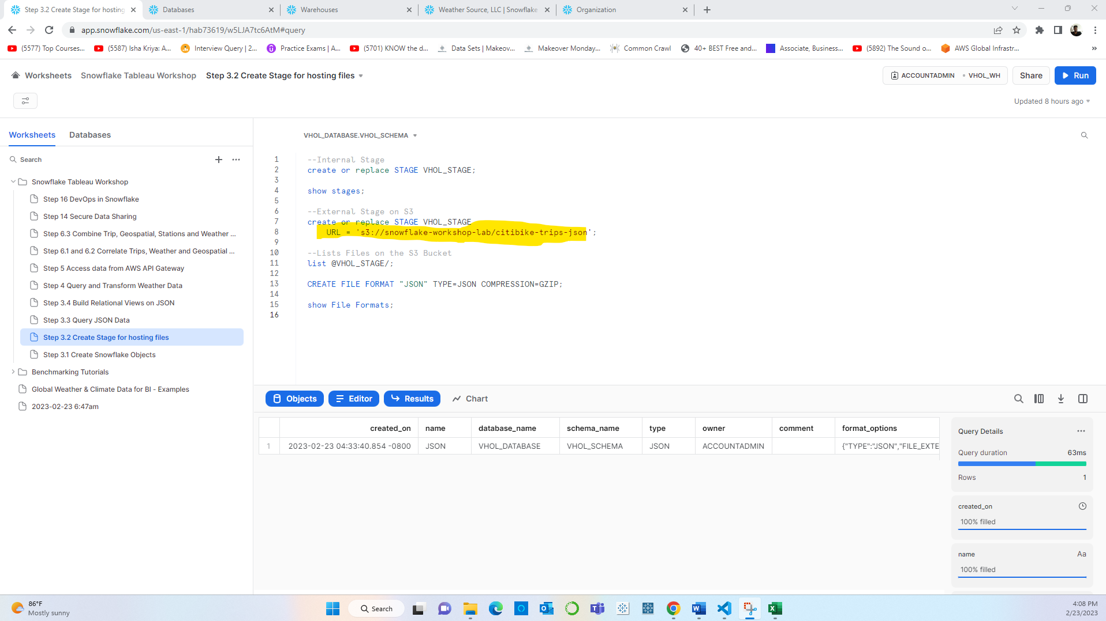

**Step 4:** Querying the trips data, which is present in the JSON format, to verify if data was extracted correctly:

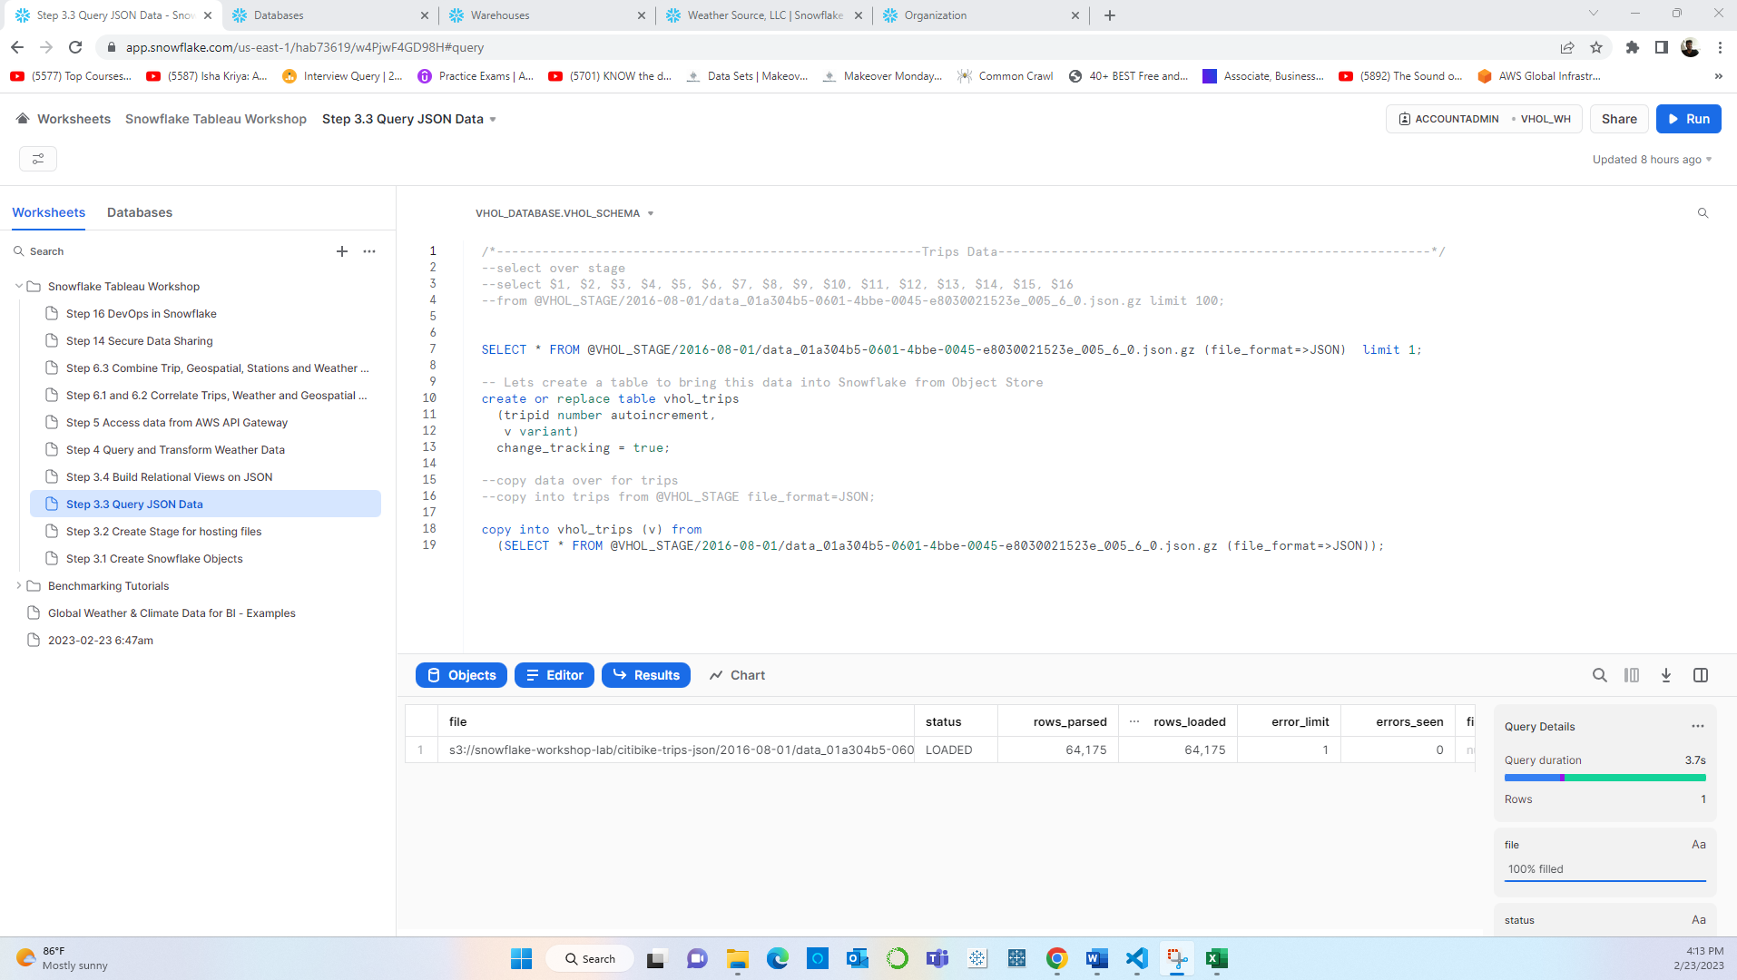

**Step 5:** Creating relational views from the JSON data

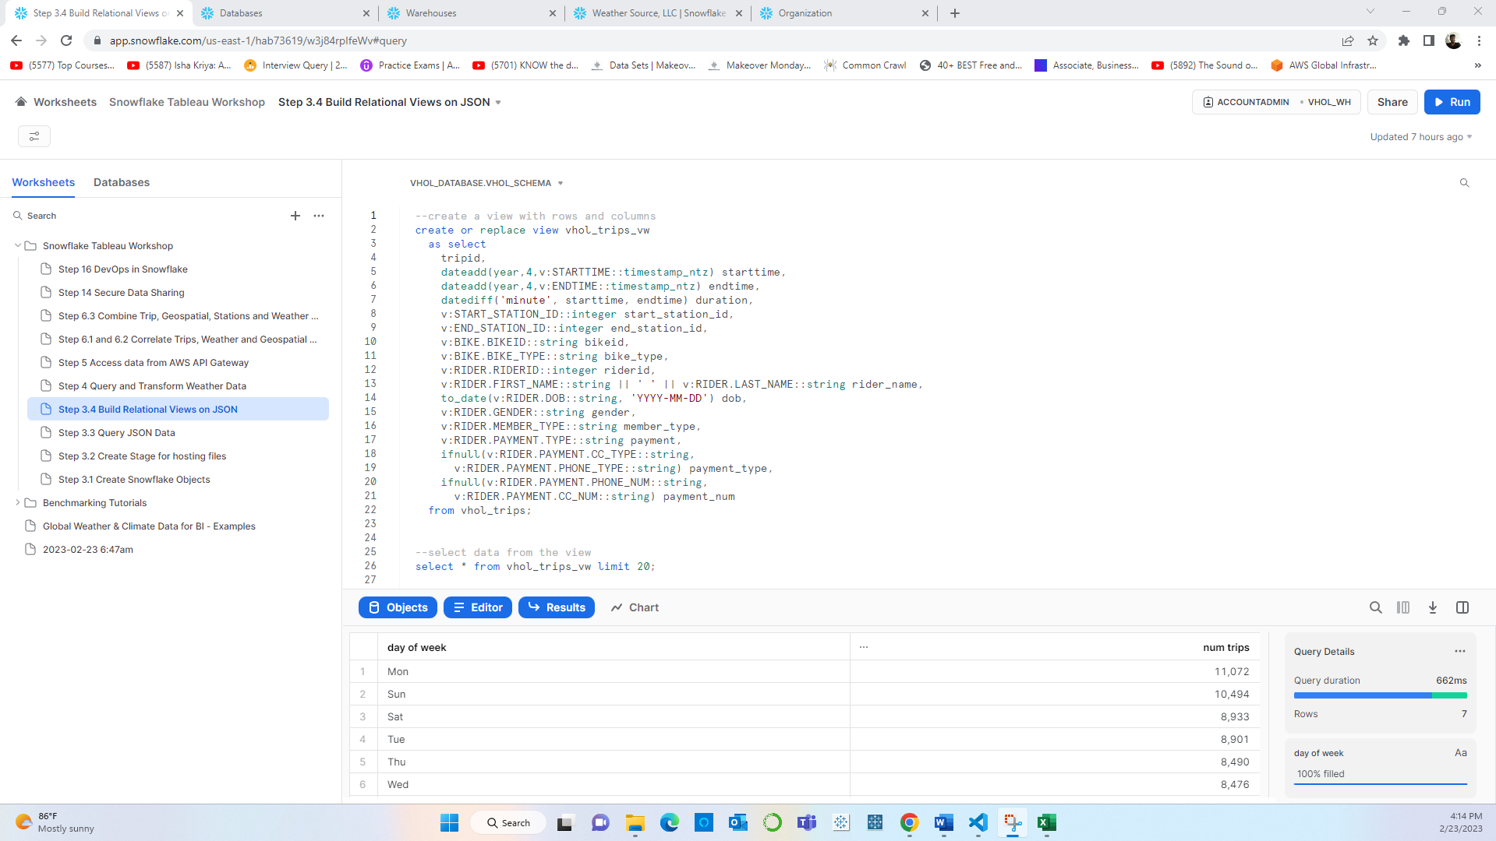

**Step 6:** After extracting weather data from **Snowflake marketplace**, Querying and transforming the weather data.

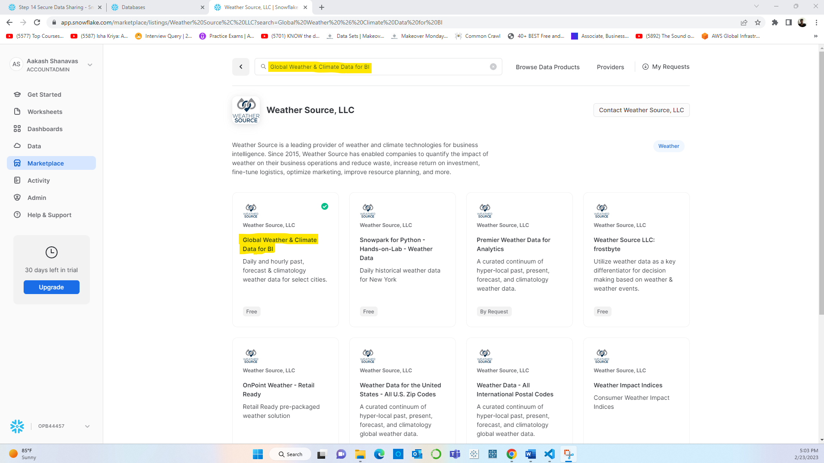

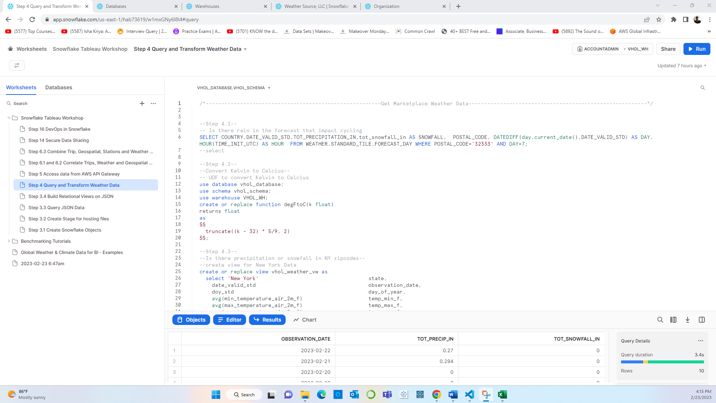

**Step 7:** Using AWS lambda to get geospatial data from AWS API Gateway

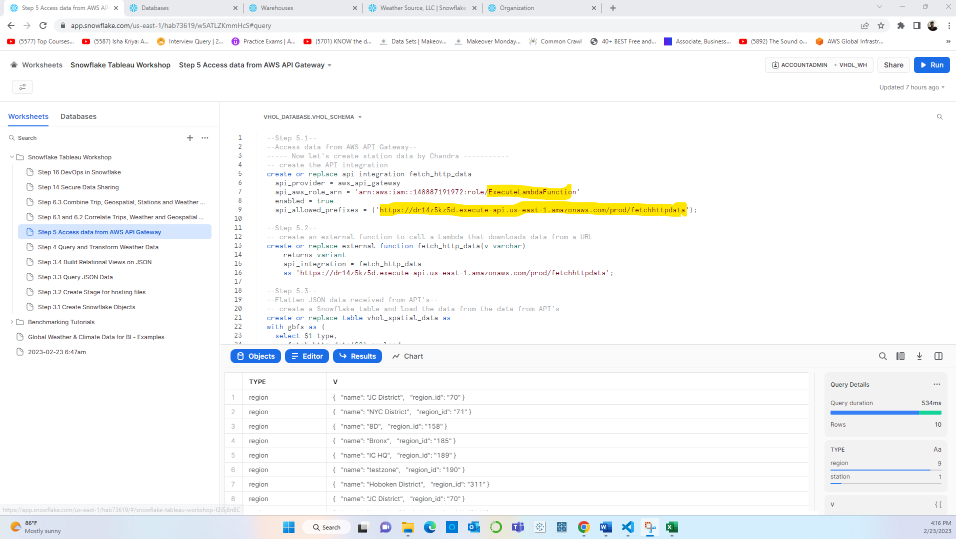

**Step 8:** Correlating all the data:

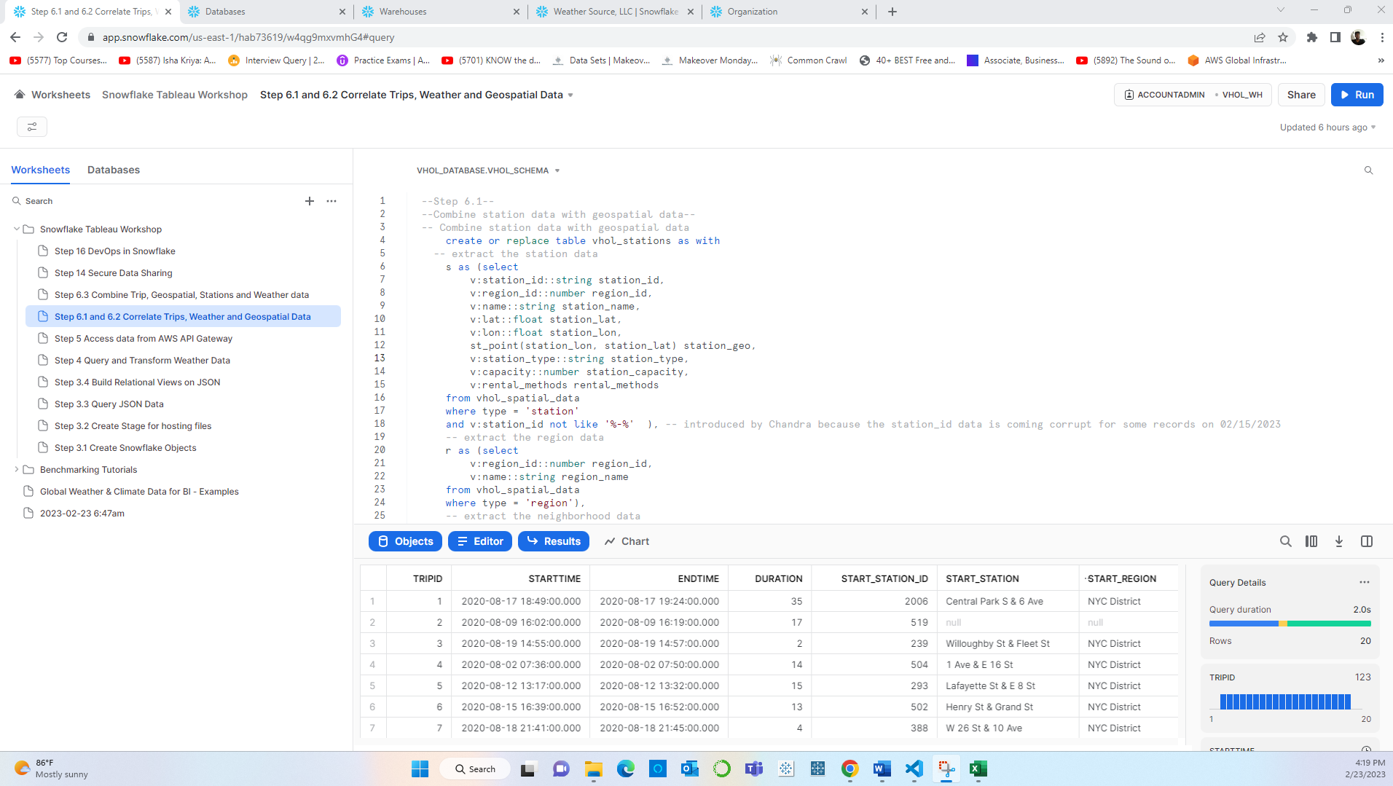

**Step 9:** Combining all the data obtained from the three different data sources.

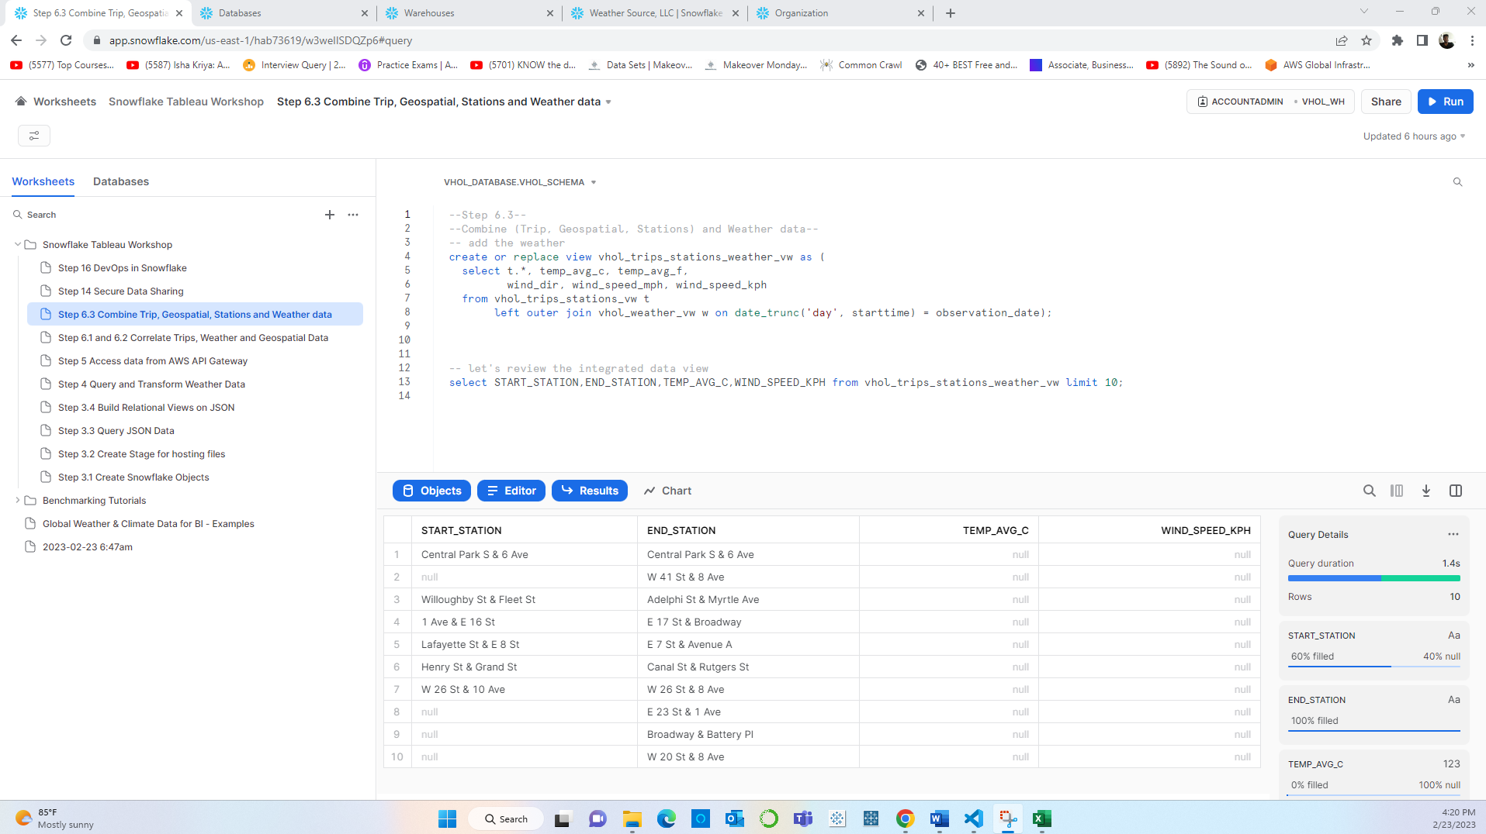

**Tableau Cloud**

**Step 10:** Connecting to Snowflake using the Snowflake connector in order to access data source.

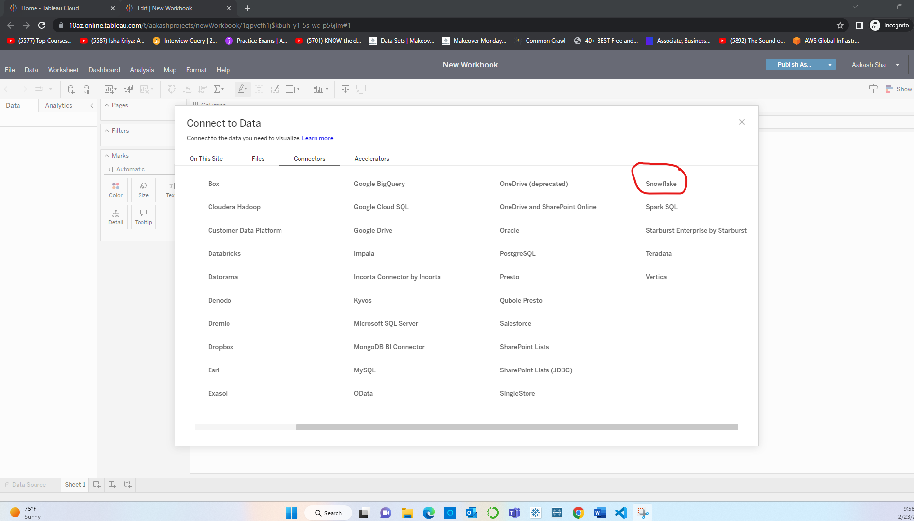

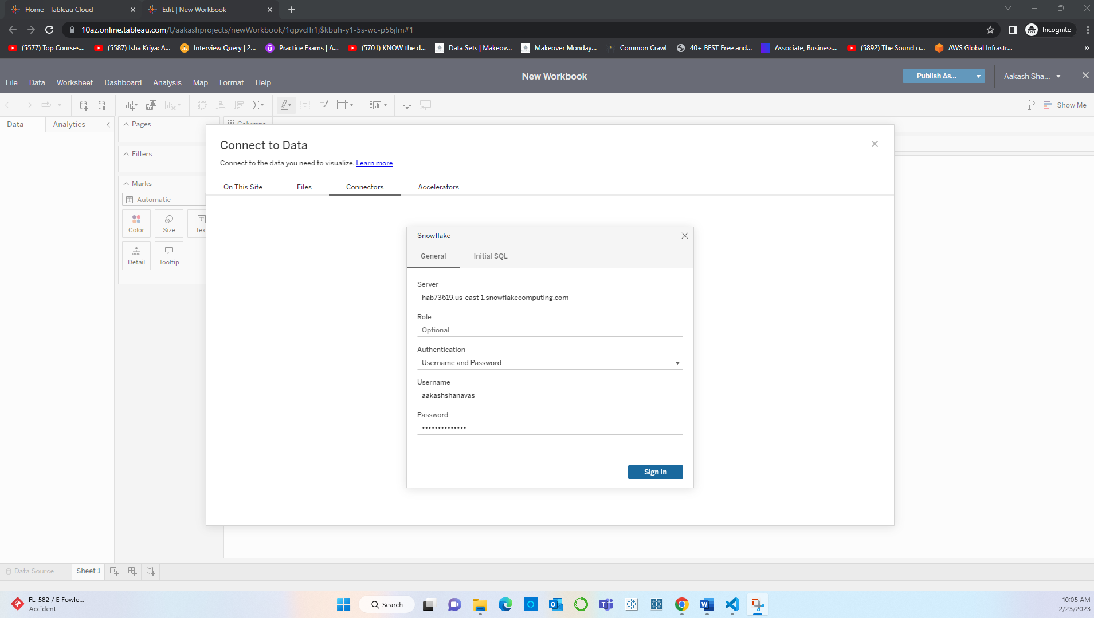

**Step 11:** Mentioning all the required snowflake objects to connect to the data source in Snowflake.

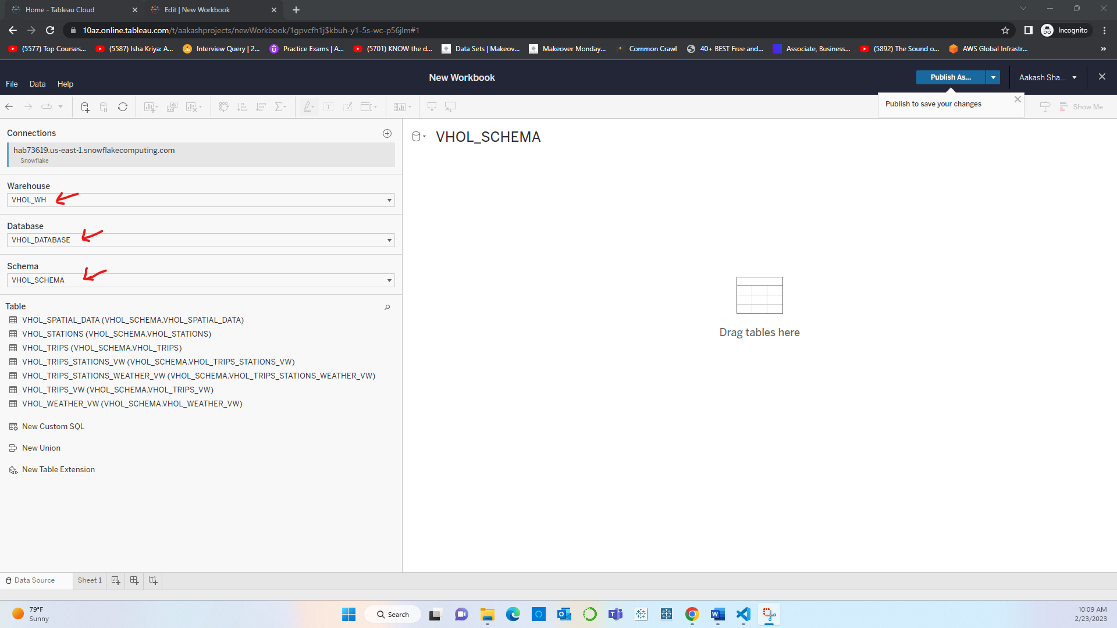

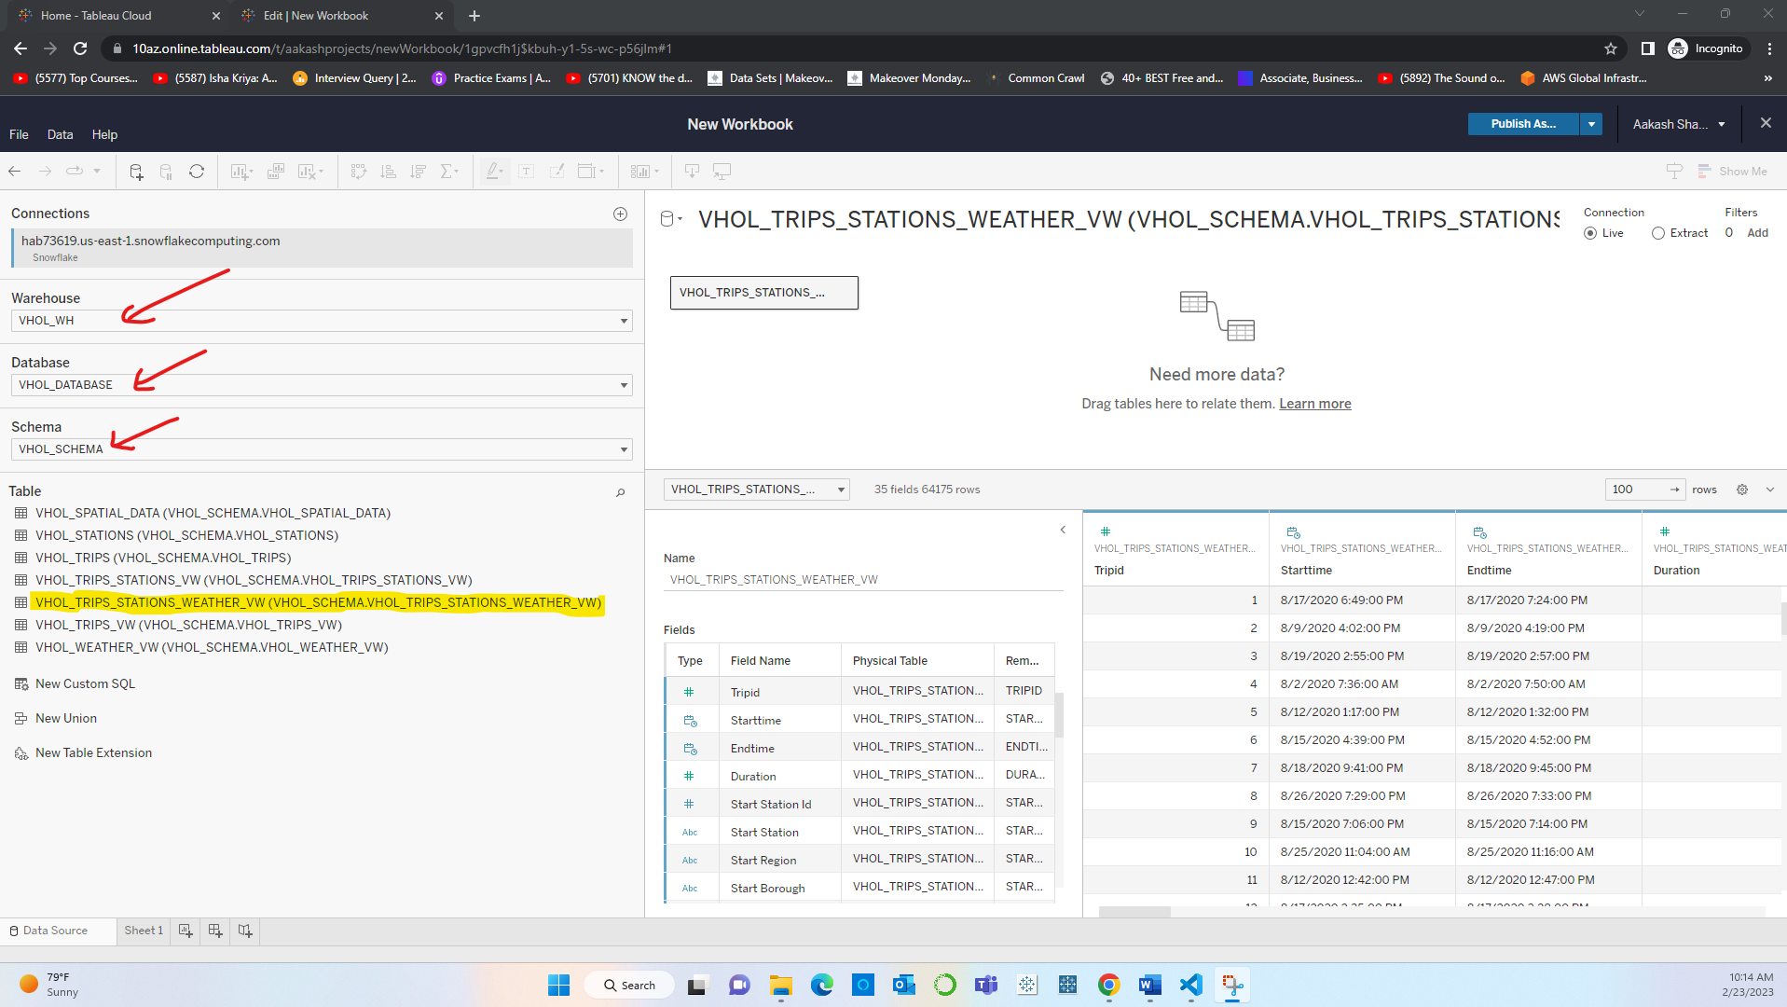

**Step 12:** Applying various Data source filters.

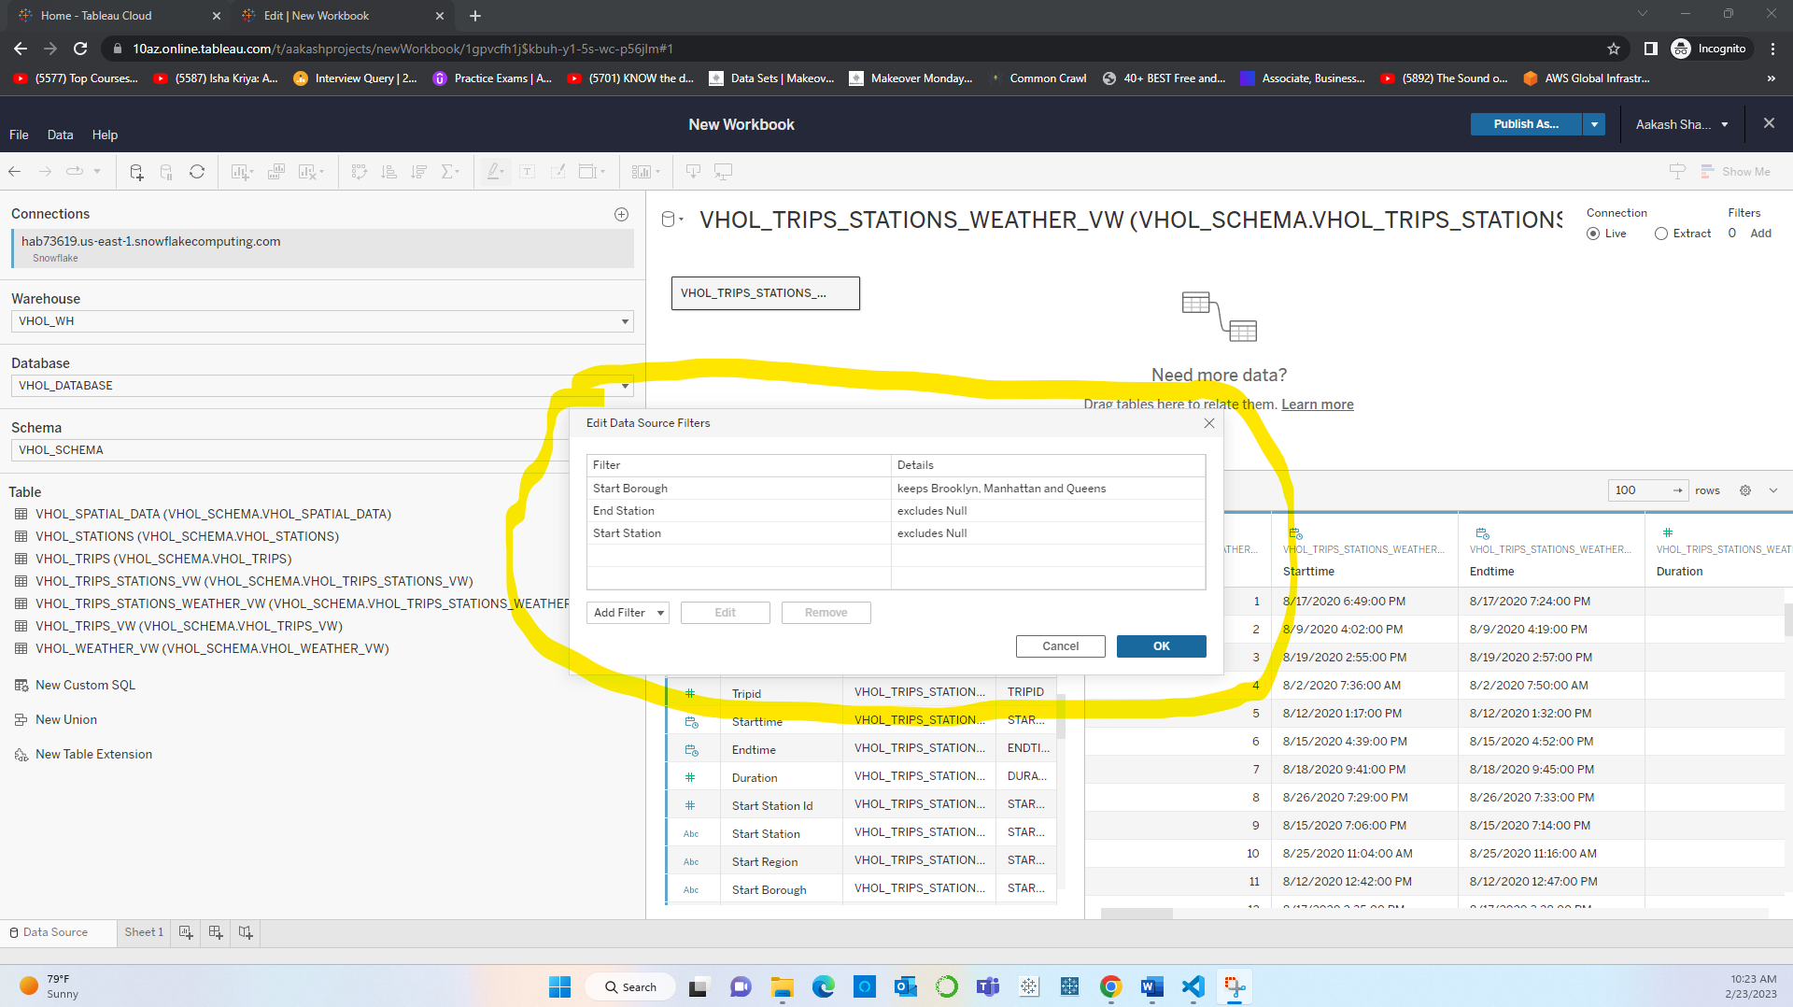

**Step 13:** Dragging the calculated field that uses MAKELINE function to create a map by plotting line between the start location and end location.

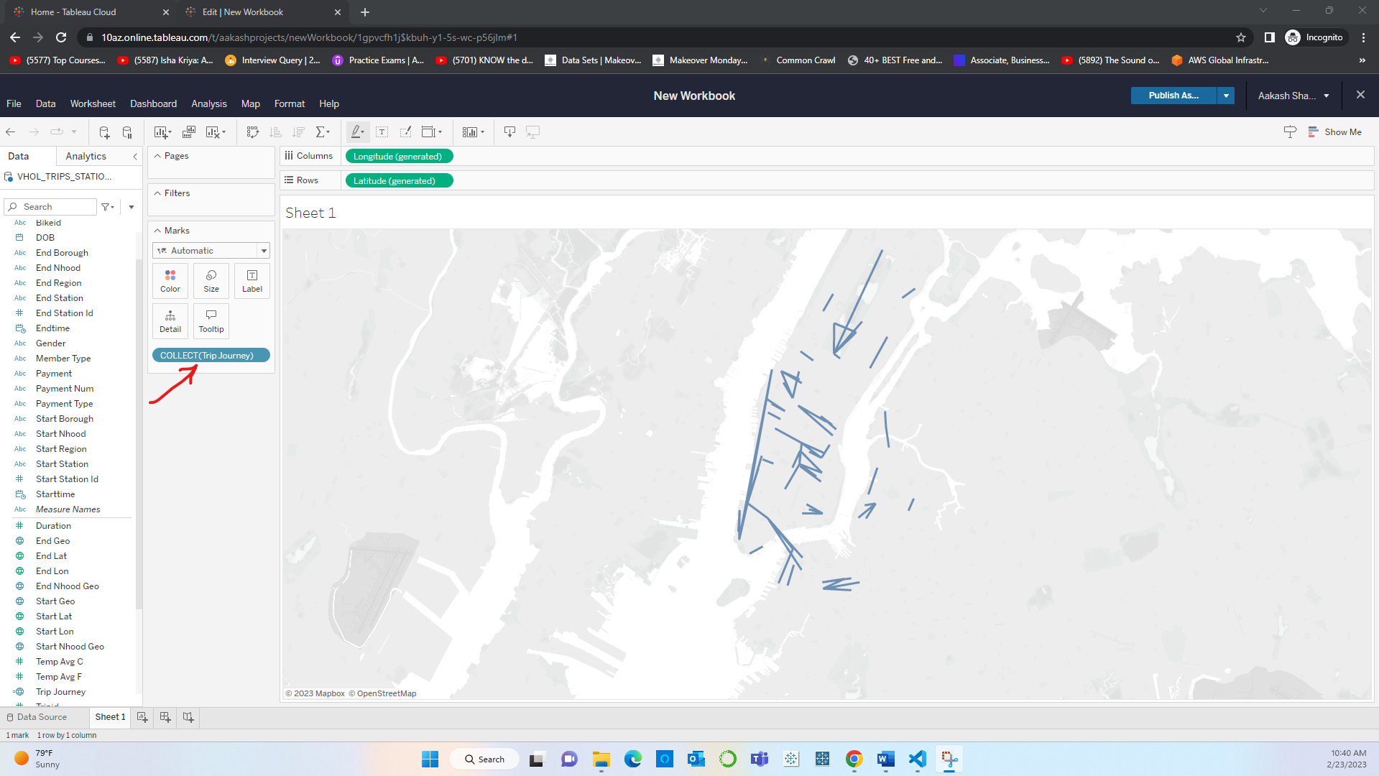

**Step 14:** As tableau groups all the trips together into a single mark, the next step is to isolate individual trips by adding following layers of detail:

1. Start Station

2. End Station

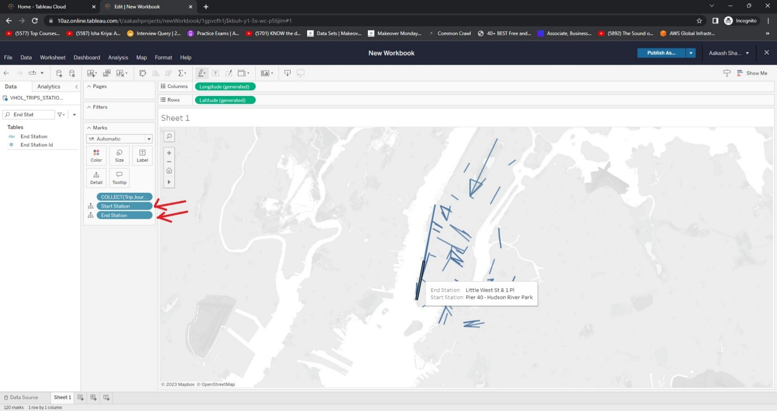

**Step 15:** Creating a calculated field to get the distinct number of trips.

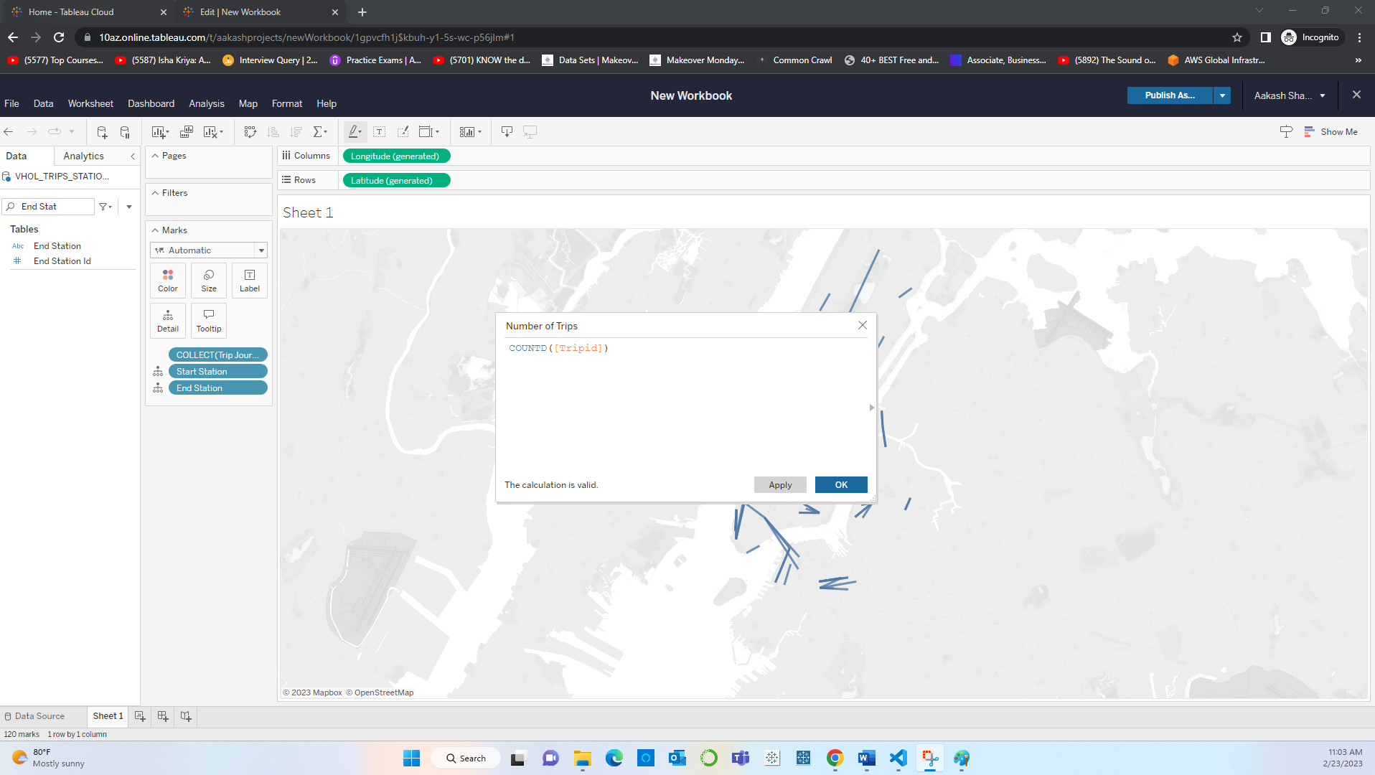

**Step 16:** Using the rich editor to make the tooltip more intuitive.

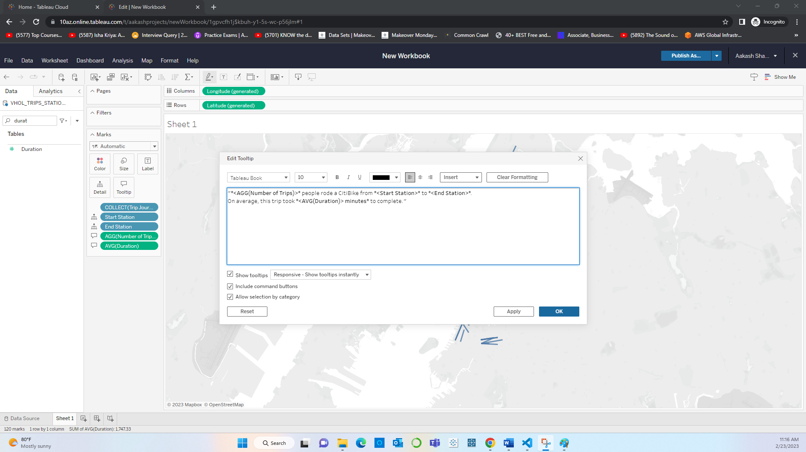

**Step 17:** Adding Map layers by bringing in the Start geo and End geo fields to denote the starting and ending points for each ride.

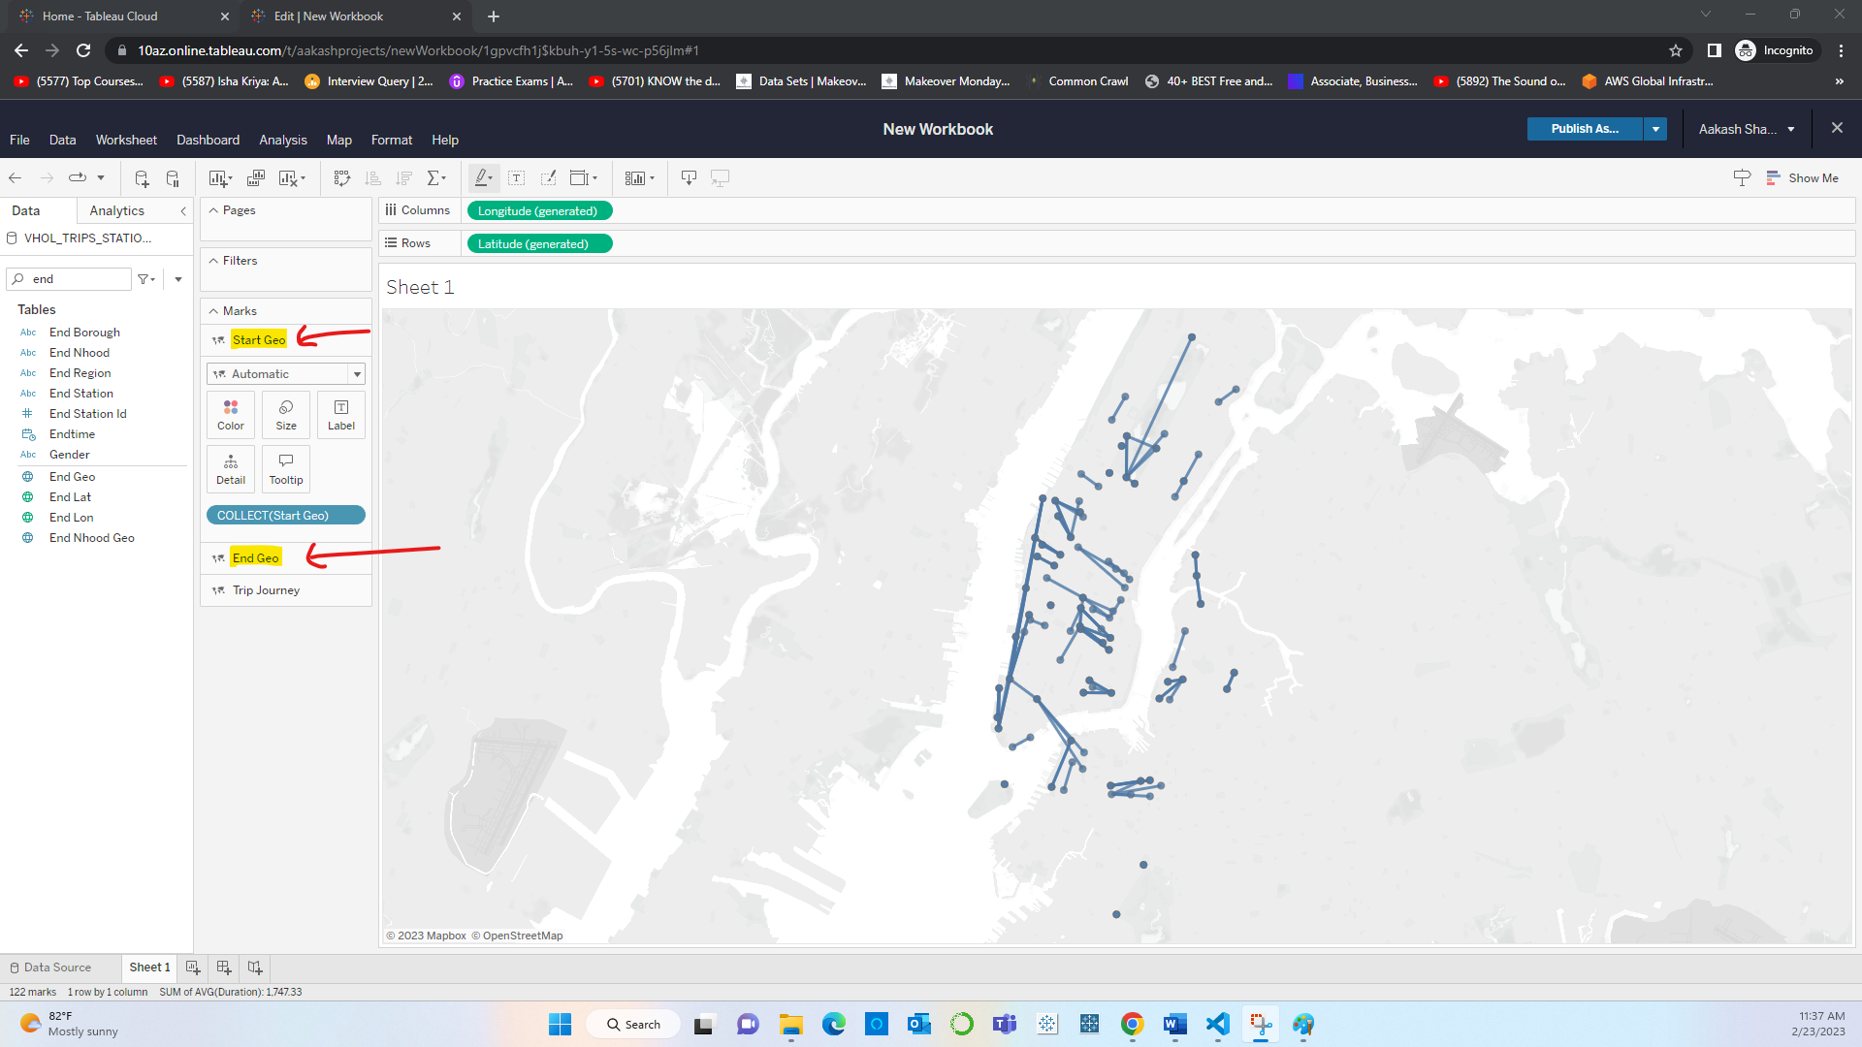

**Step 18:** Formatting the Map Layers – Yellow dots show the starting point while the green ones show the ending points of a trip. This is followed by enhancing map by customizing backgrounds.

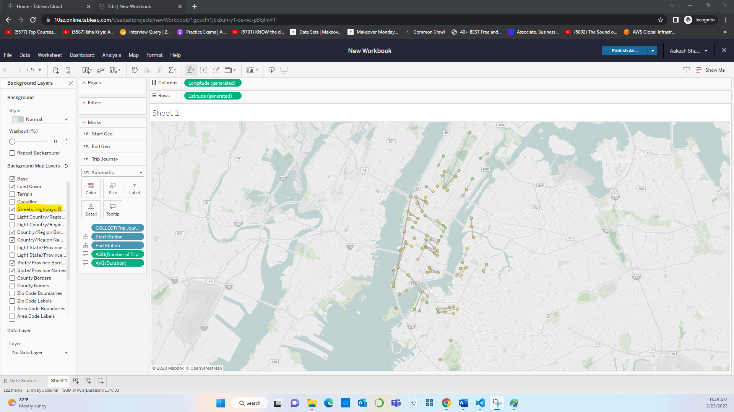

**Step 19:** Data governance: Renaming title and sheet names for better understand of the visualization.

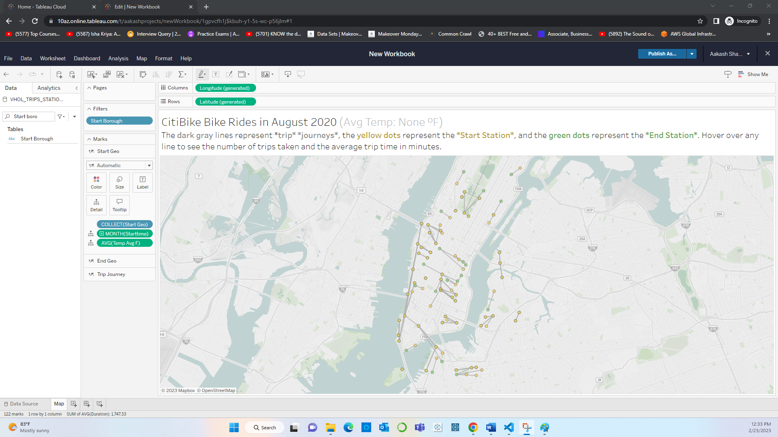

**Step 20:** Creating Dashboard and publishing it.

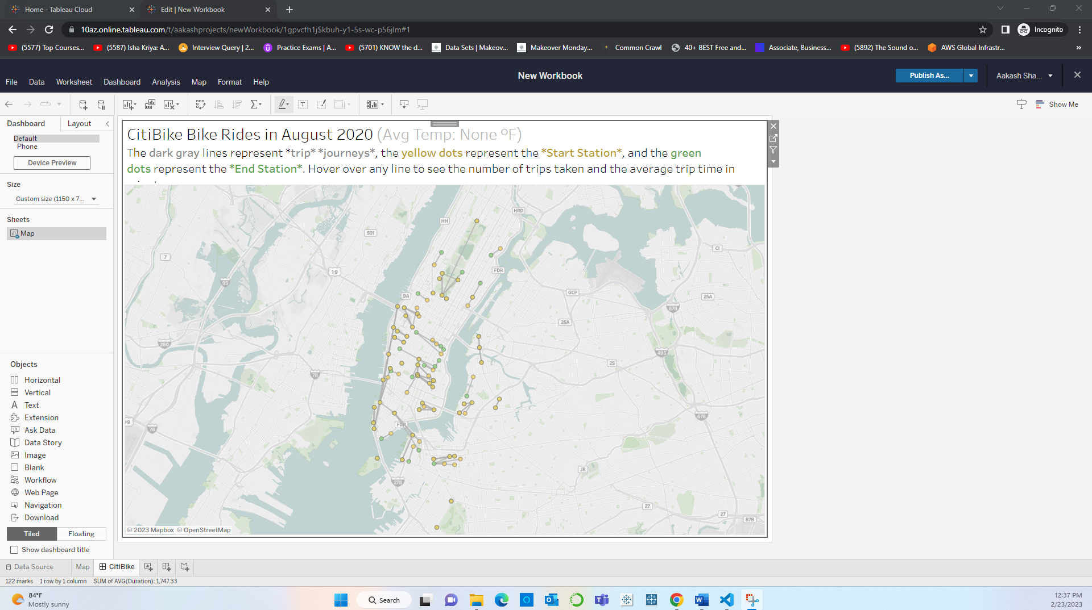

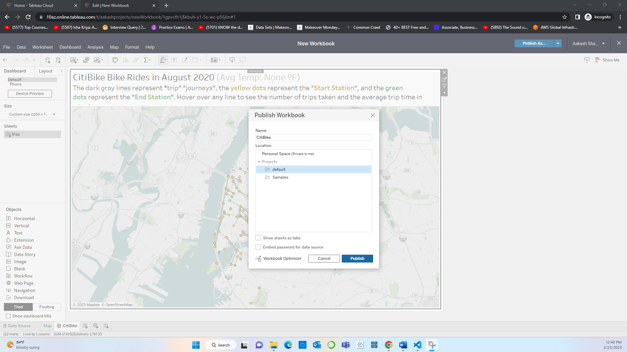

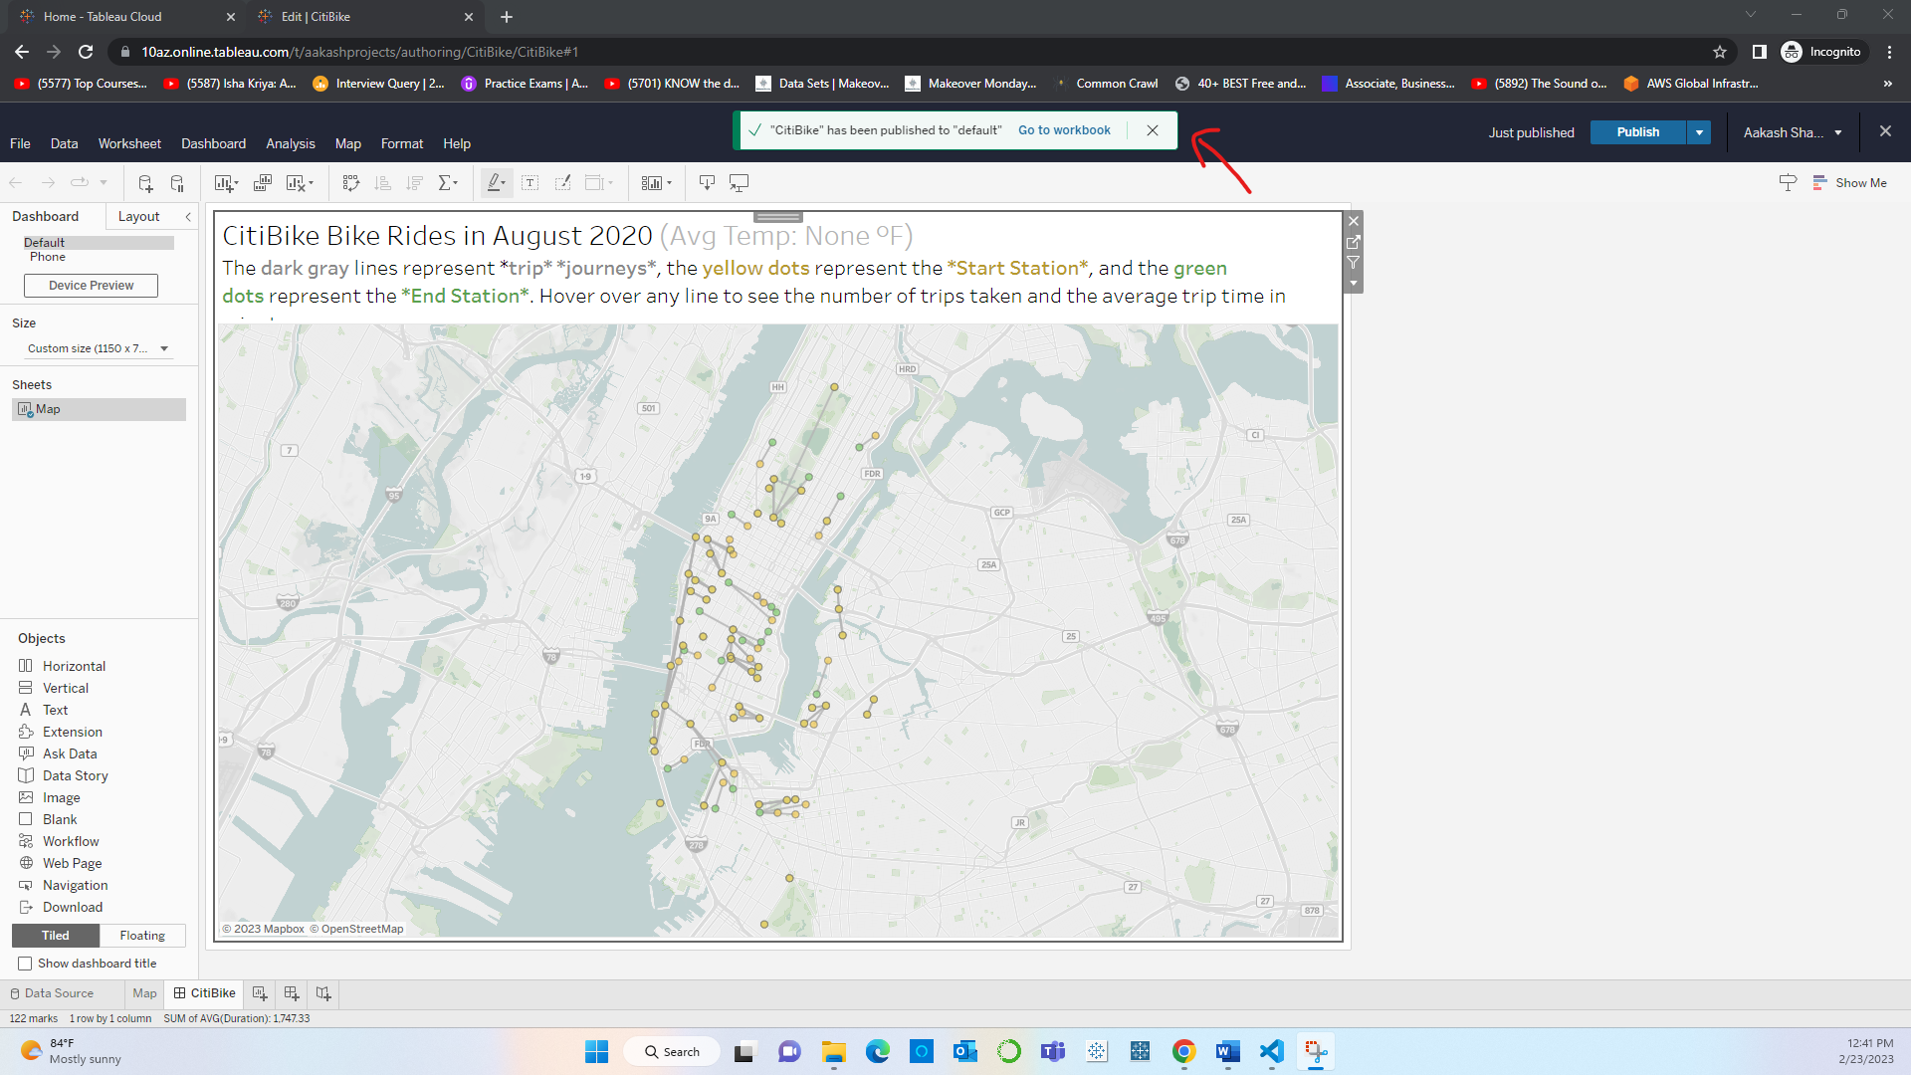

**Step 21:** Embedding the published dashboard into a Web Page

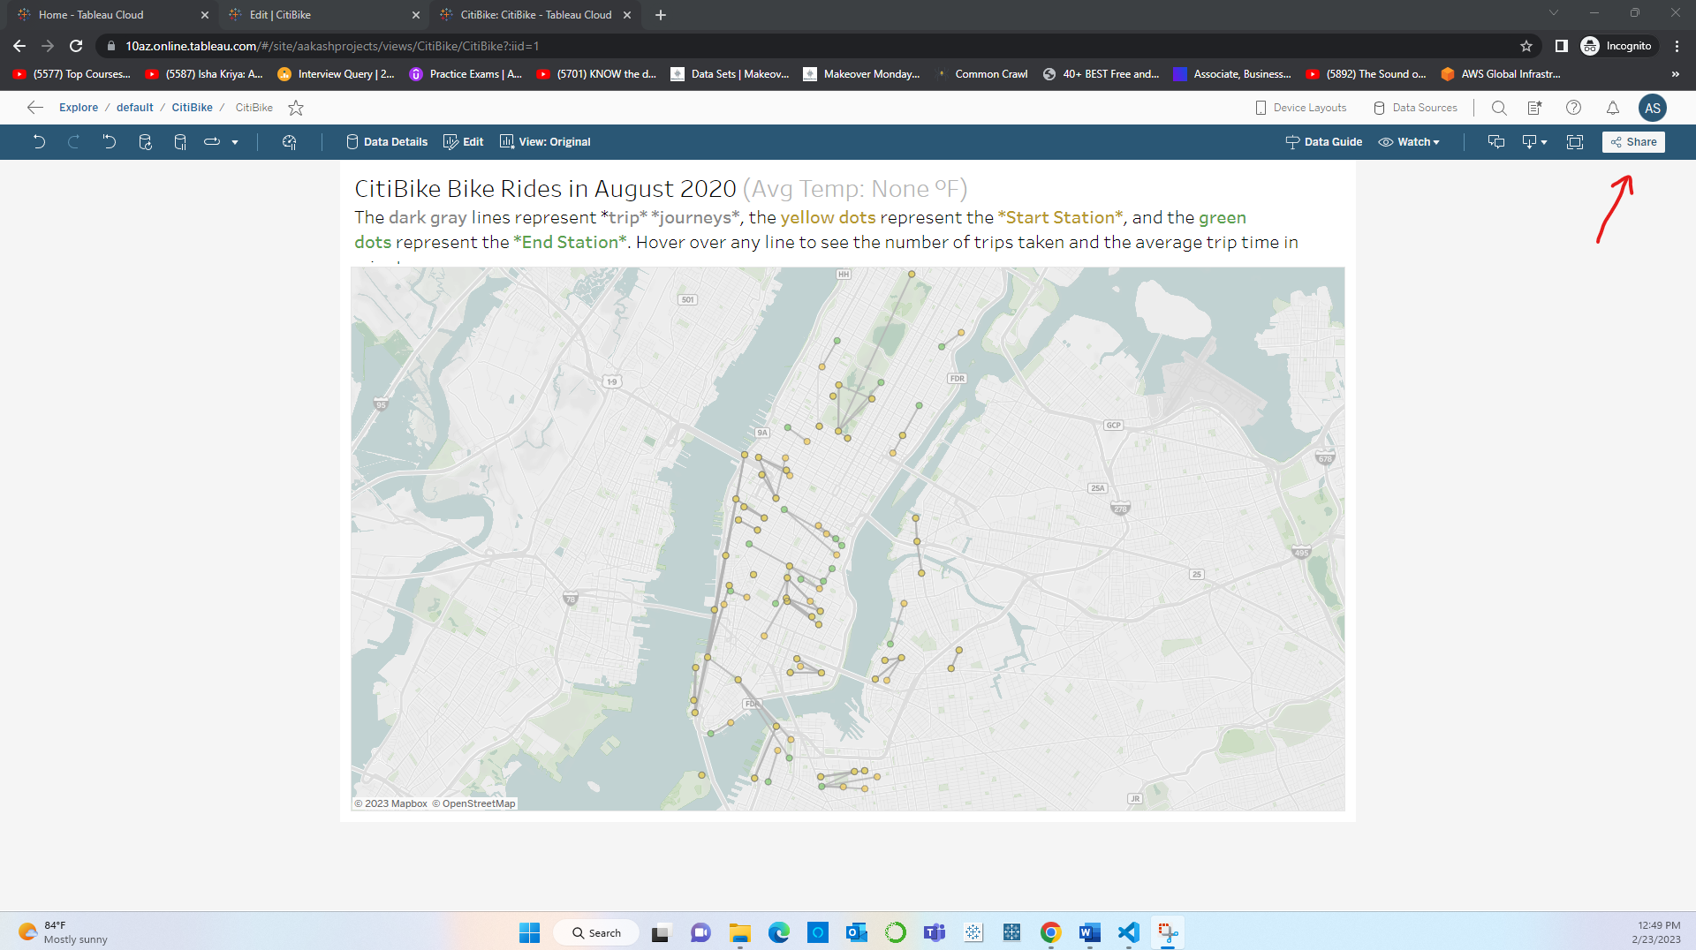

**Step 22:** Pasting the URL of the published workbook into the JavaScript file.

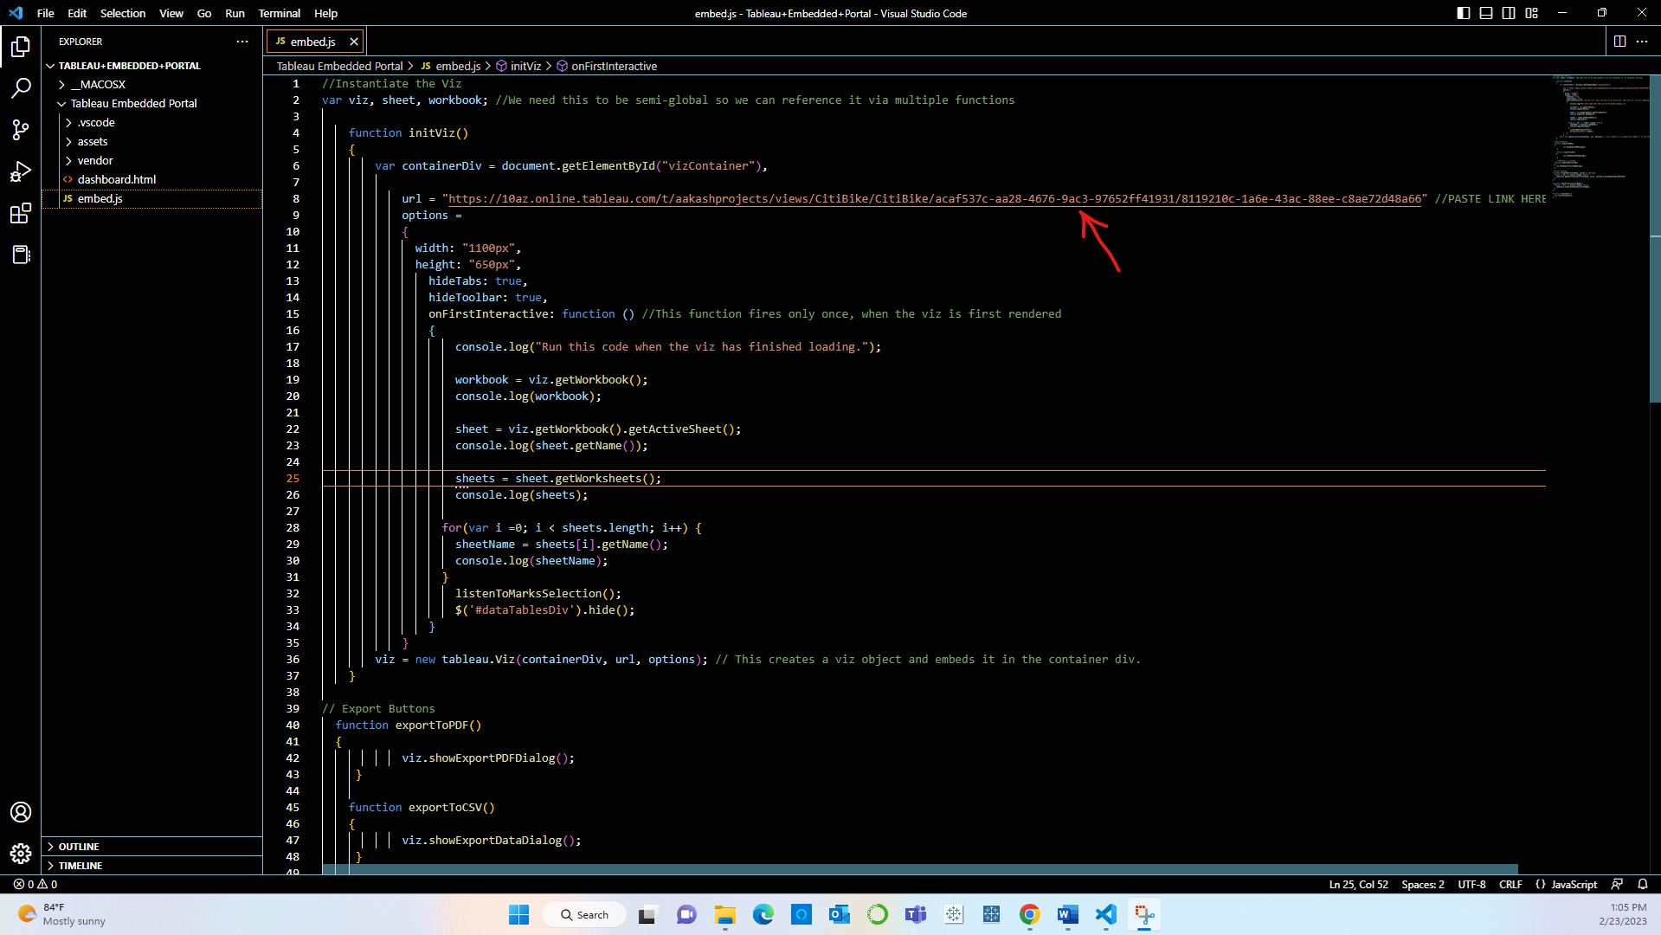

**Step 23:** Opening the dashboord in the browser.

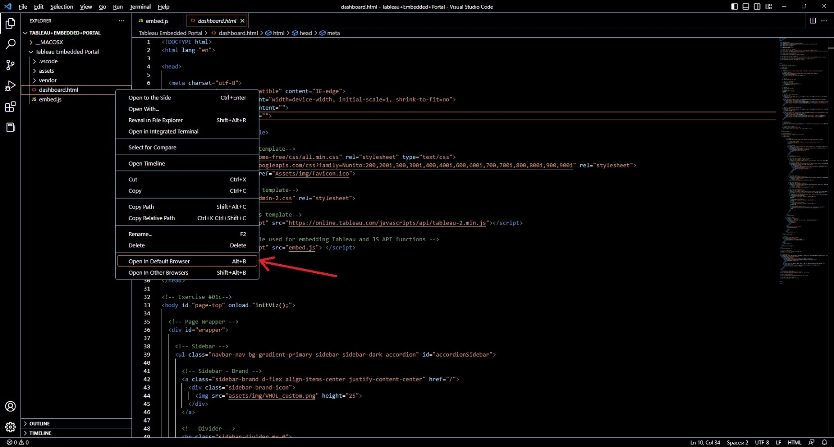

**Step 24:** Dashboard embedded into an external Web Application. Also understanding how Tableau’s JavaScript API is leveraged to translate any selections that are made in the external webpage into filters within tableau.

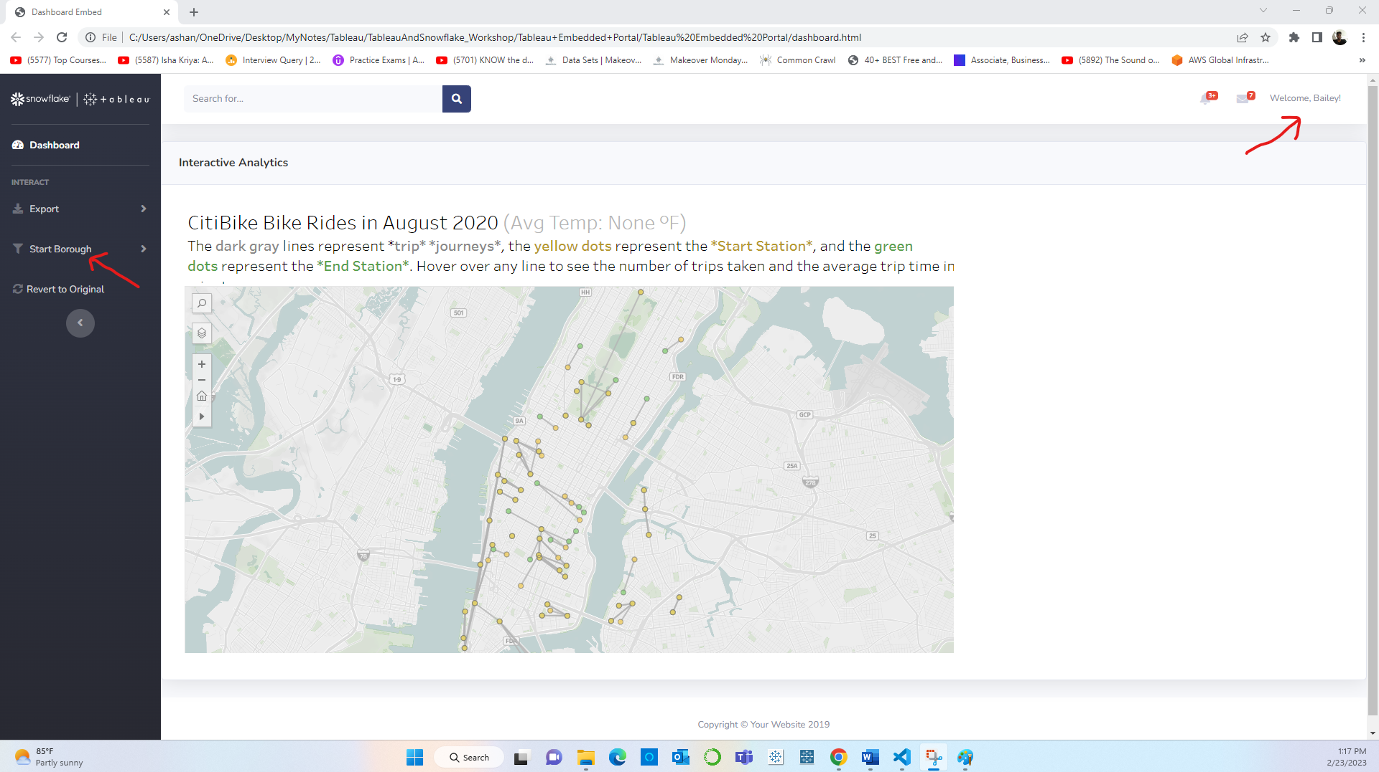

**Step 25:** Following snippet below only shows the trips that started from Brooklyn.

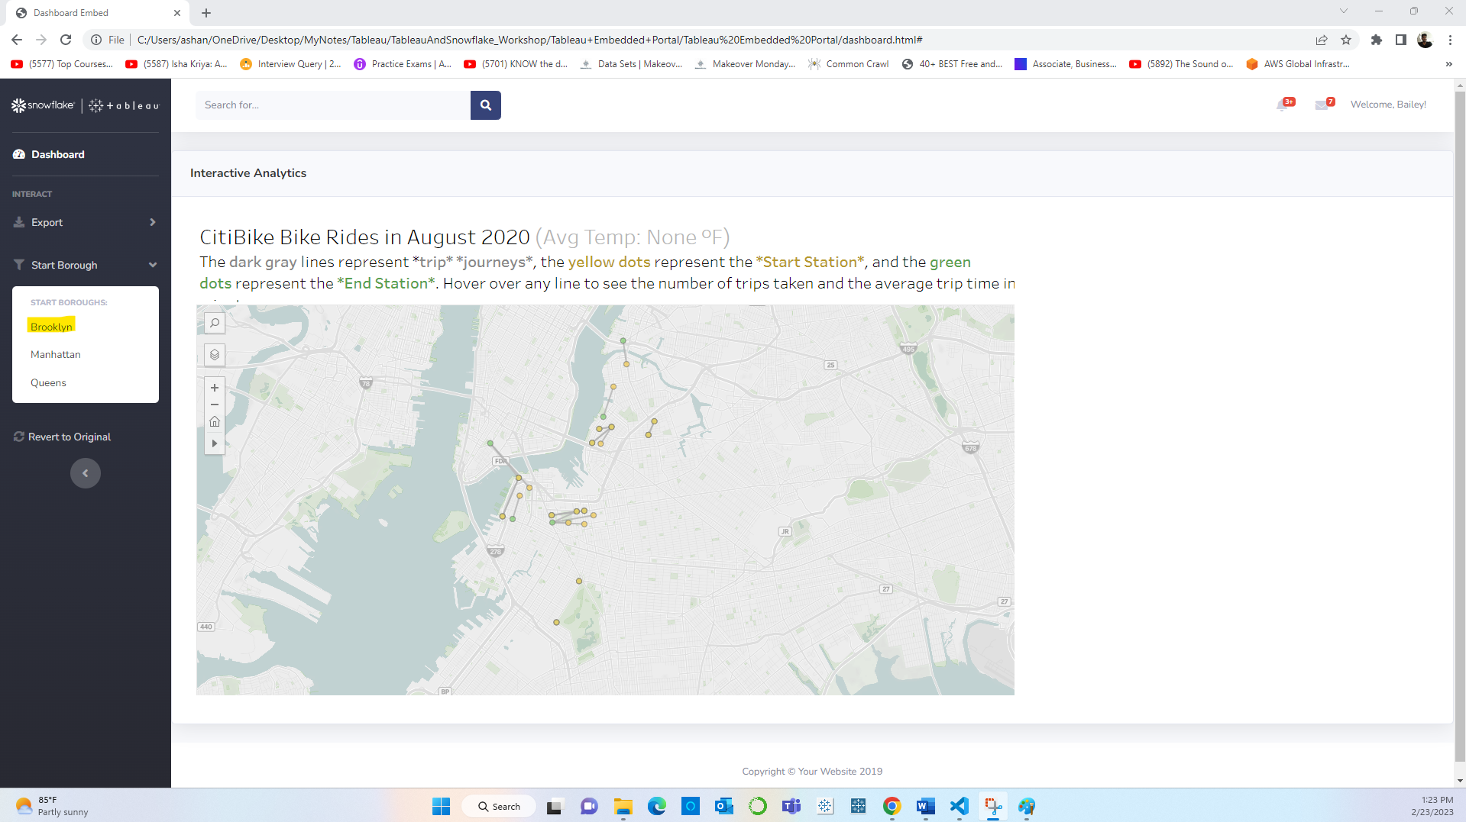

**SNOWFLAKE**

**Step 26:**

Creating the reader account and identifying all the necessary detail to share with the client including account_name, username, password and URL.

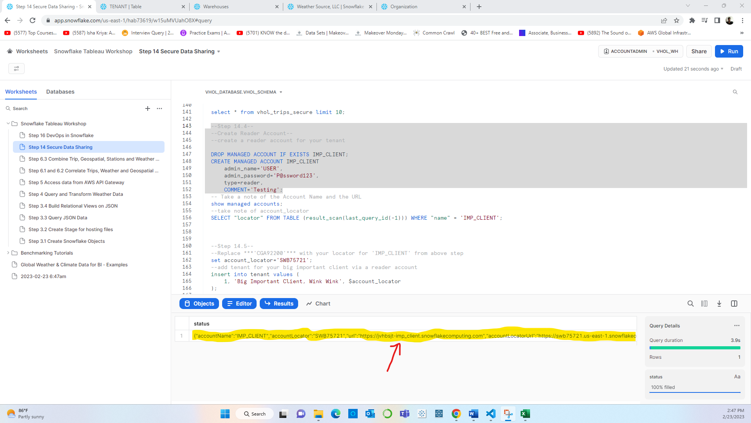

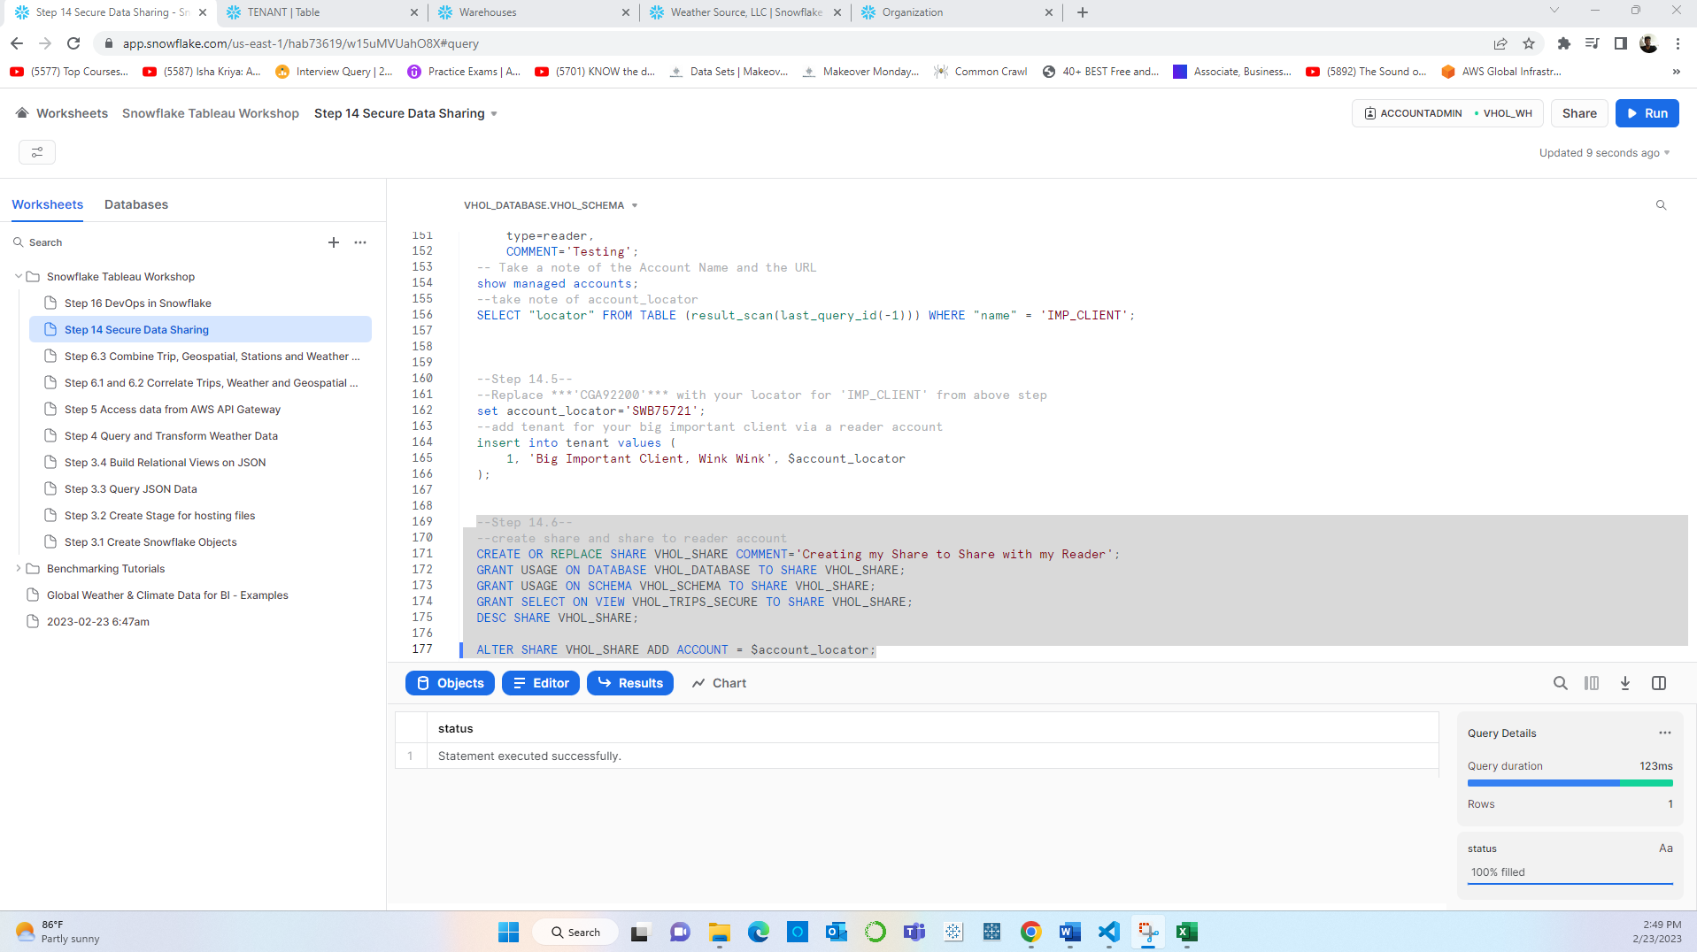

**SNOWSIGHT**

**Step 27:** Logging into the reader Account **Snowsight**:

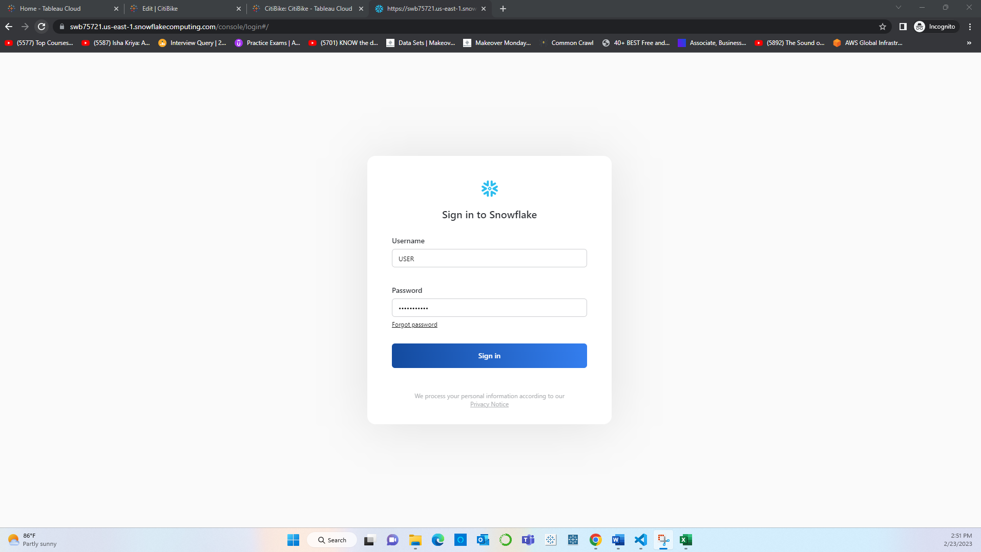

**Step 28:** Navigating to Snowsight:

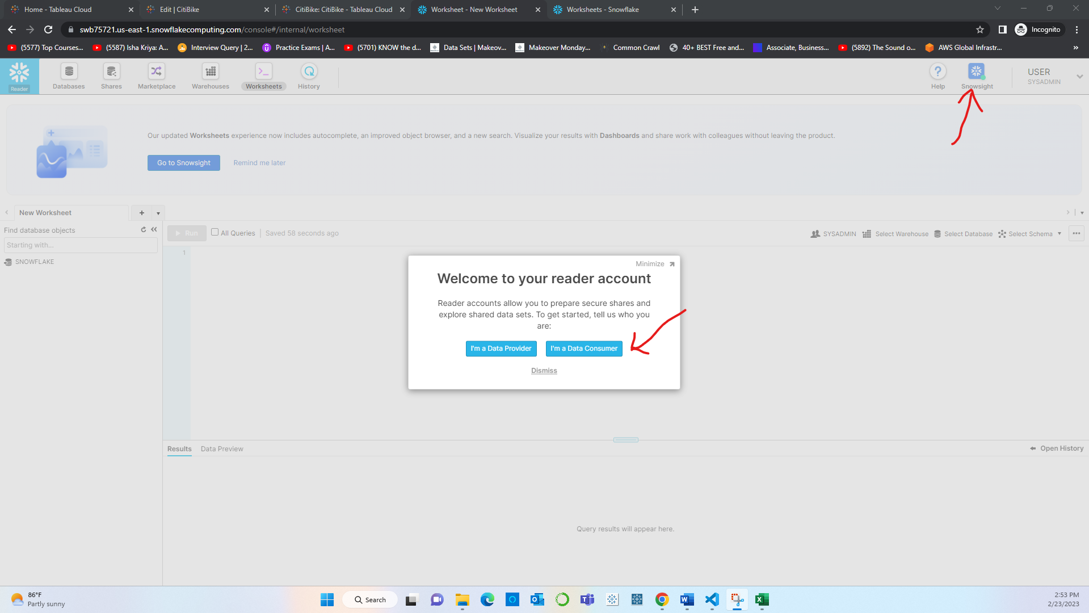

**Step 29:** Creating database inside Reader Account.

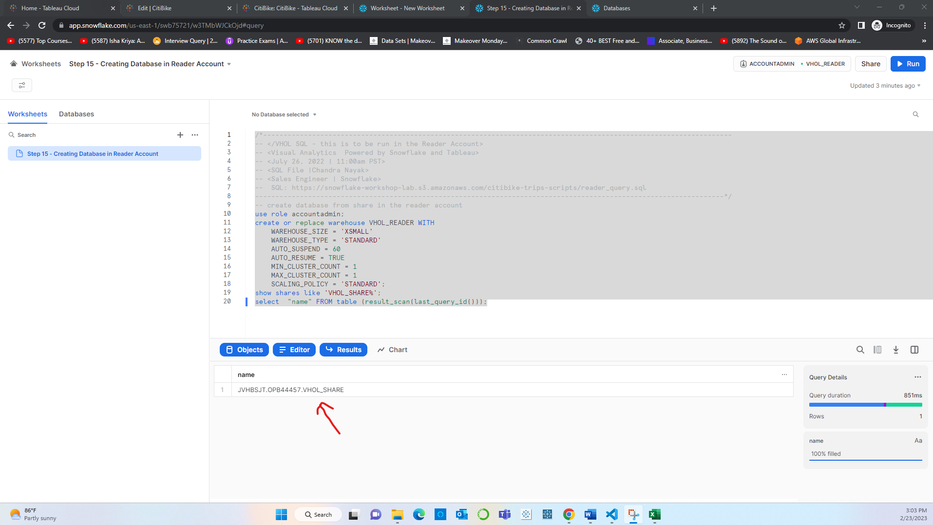

**Step 30:** Databases inside Snowsight:

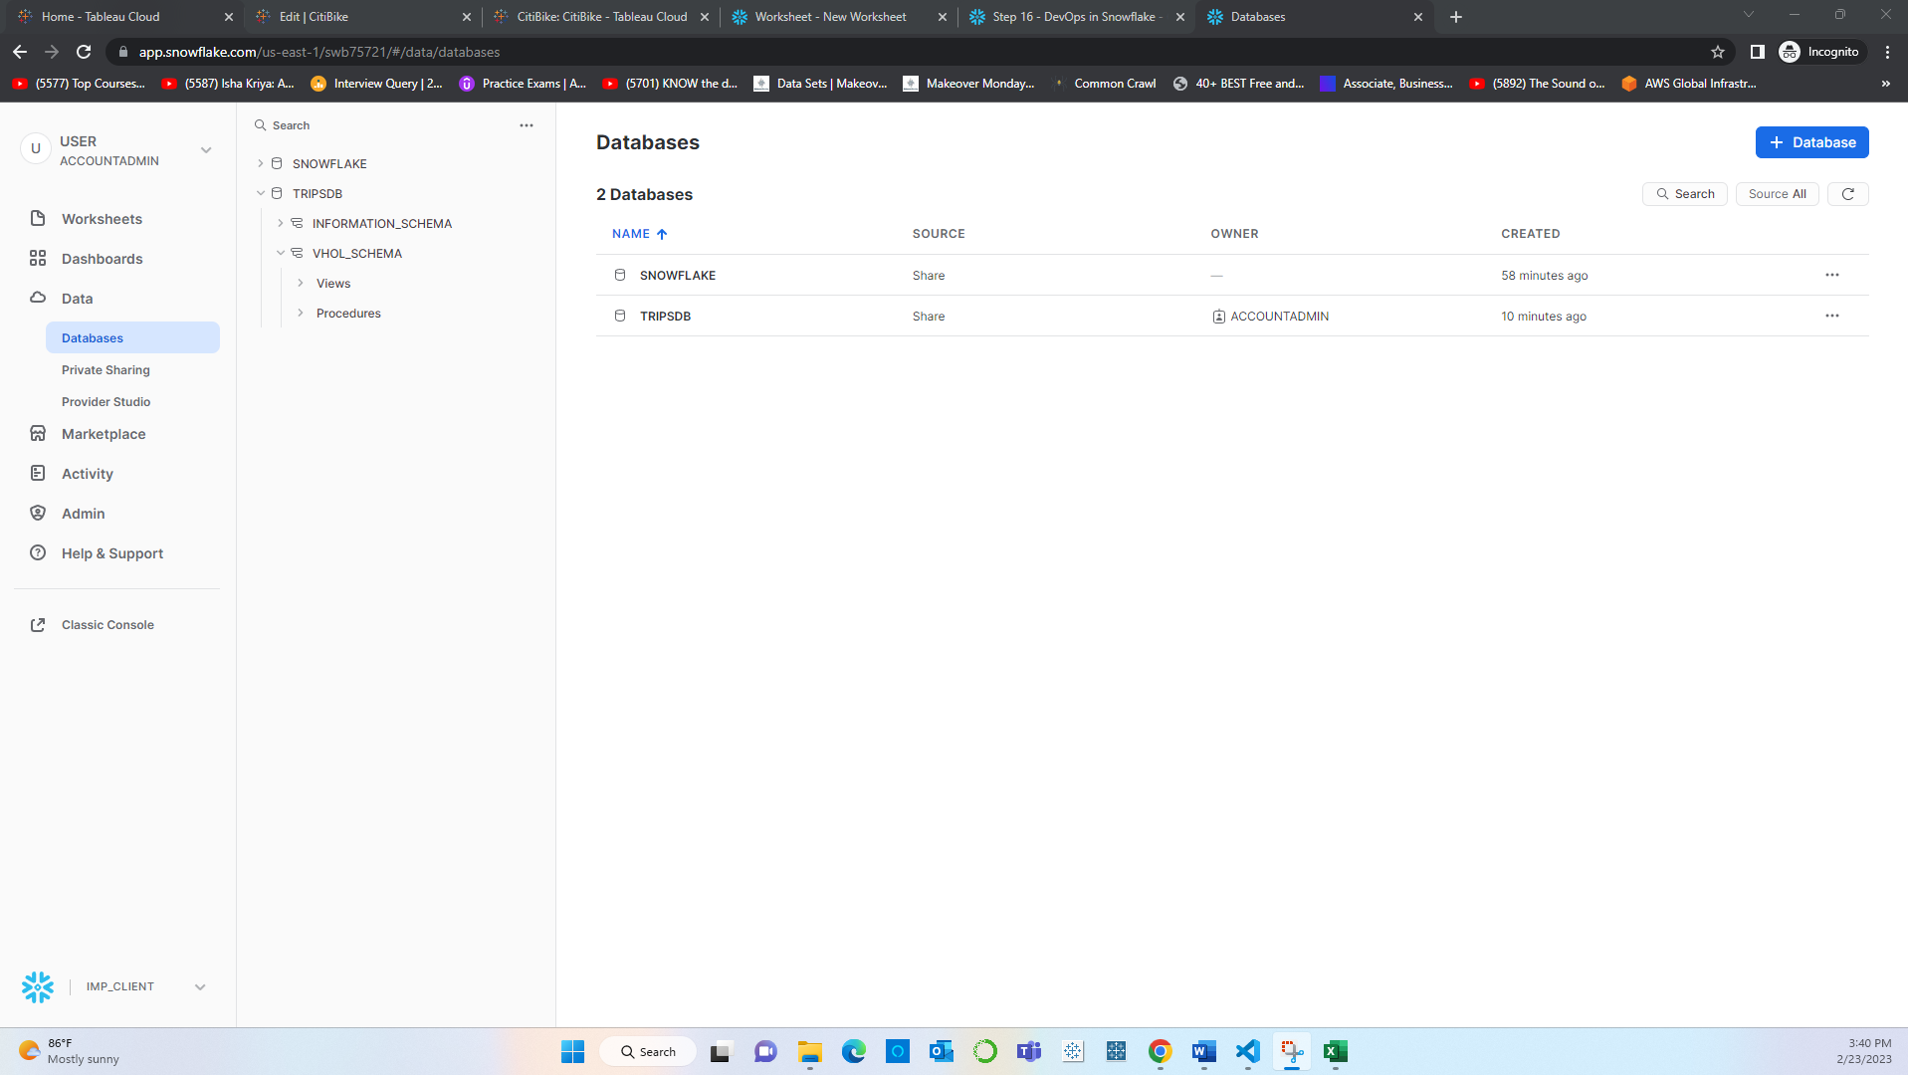

**Step 31:** The Client can now access the shared Data:

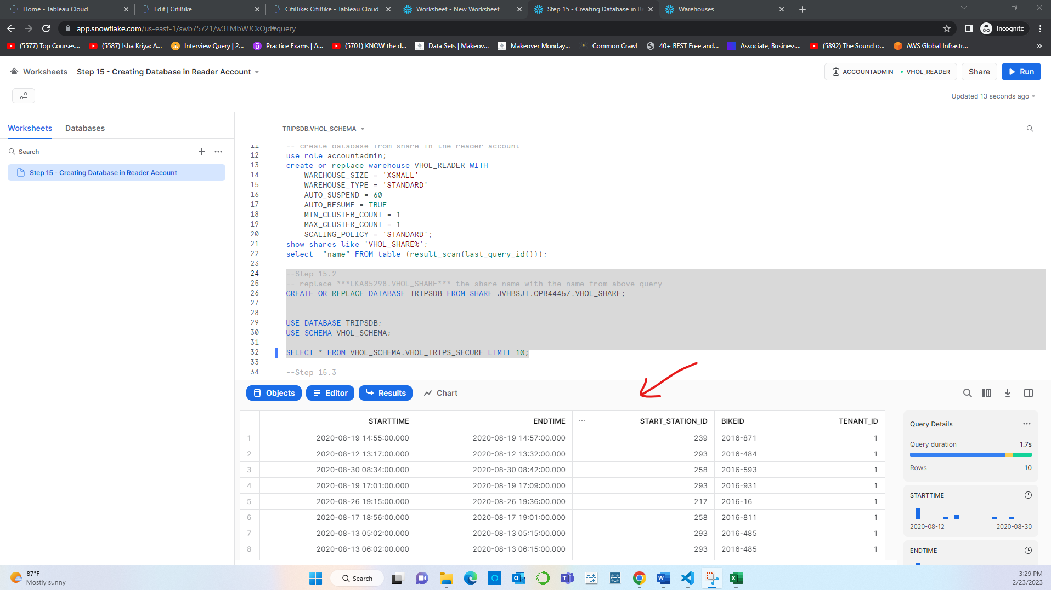

**Step 33:** DevOps in Snowflake which include:

Cloning the trips table into a dummy table.

Dropping and undrooping the table

Cleaning up the entire Demo Account by dropping the share

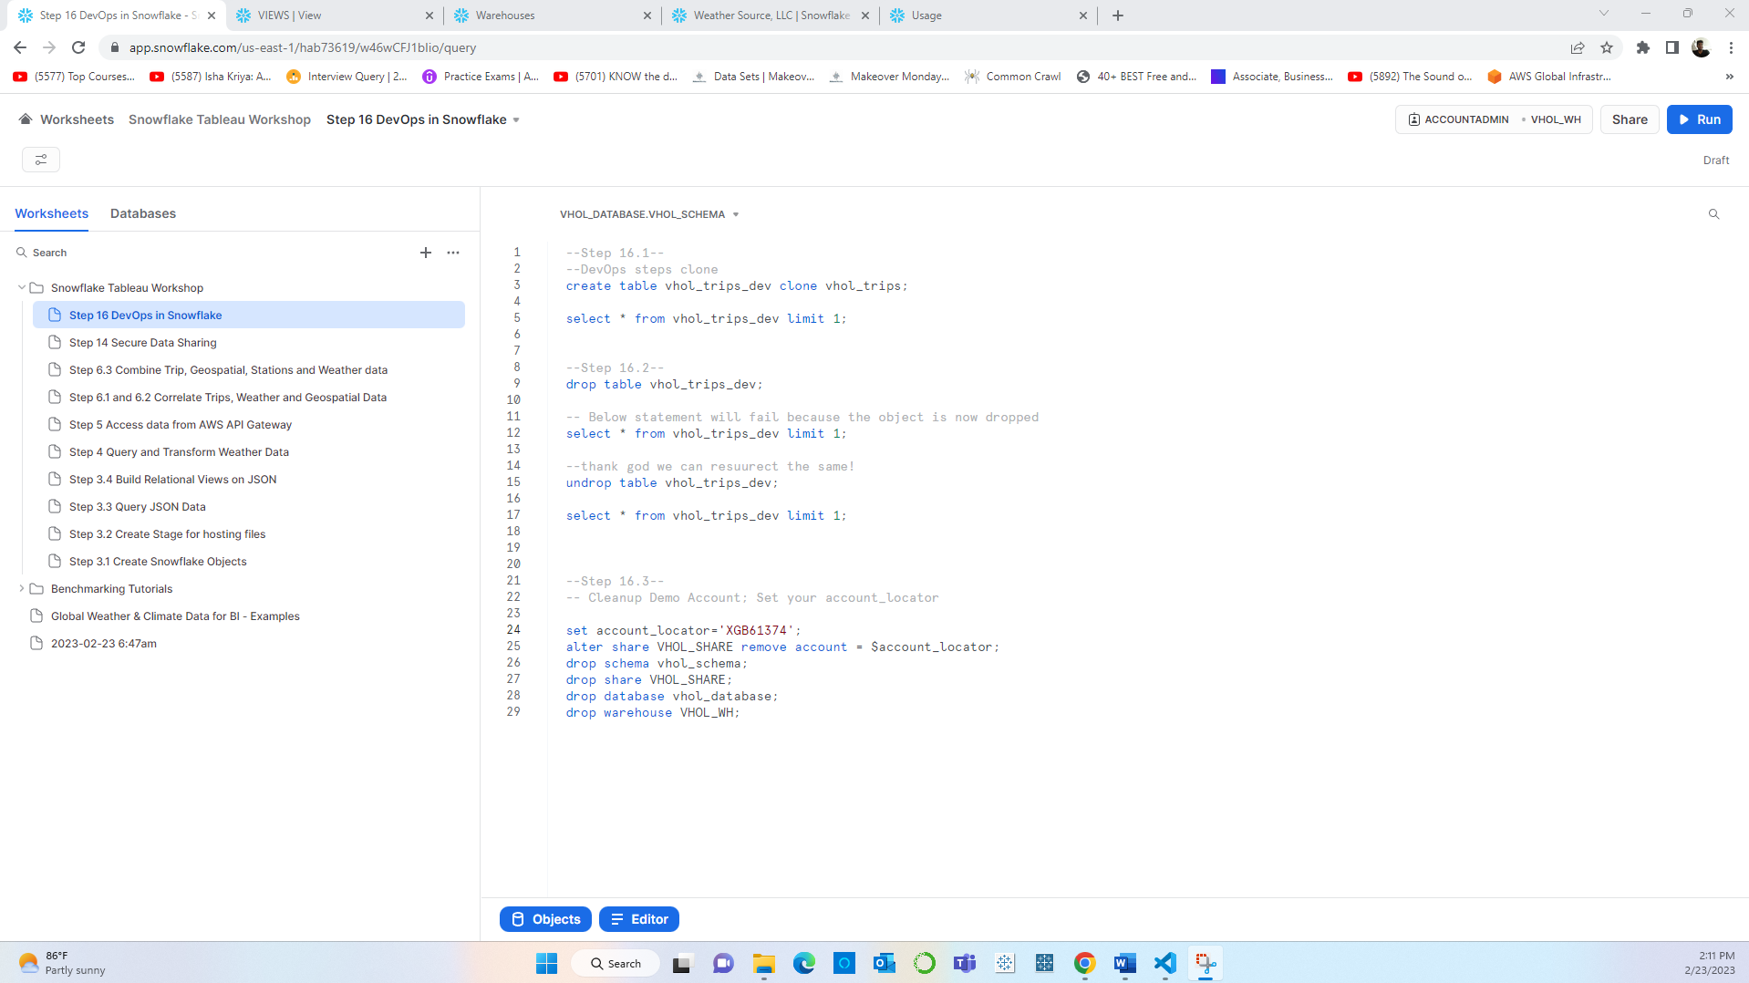

**Step 33:** Cloning a table to test:

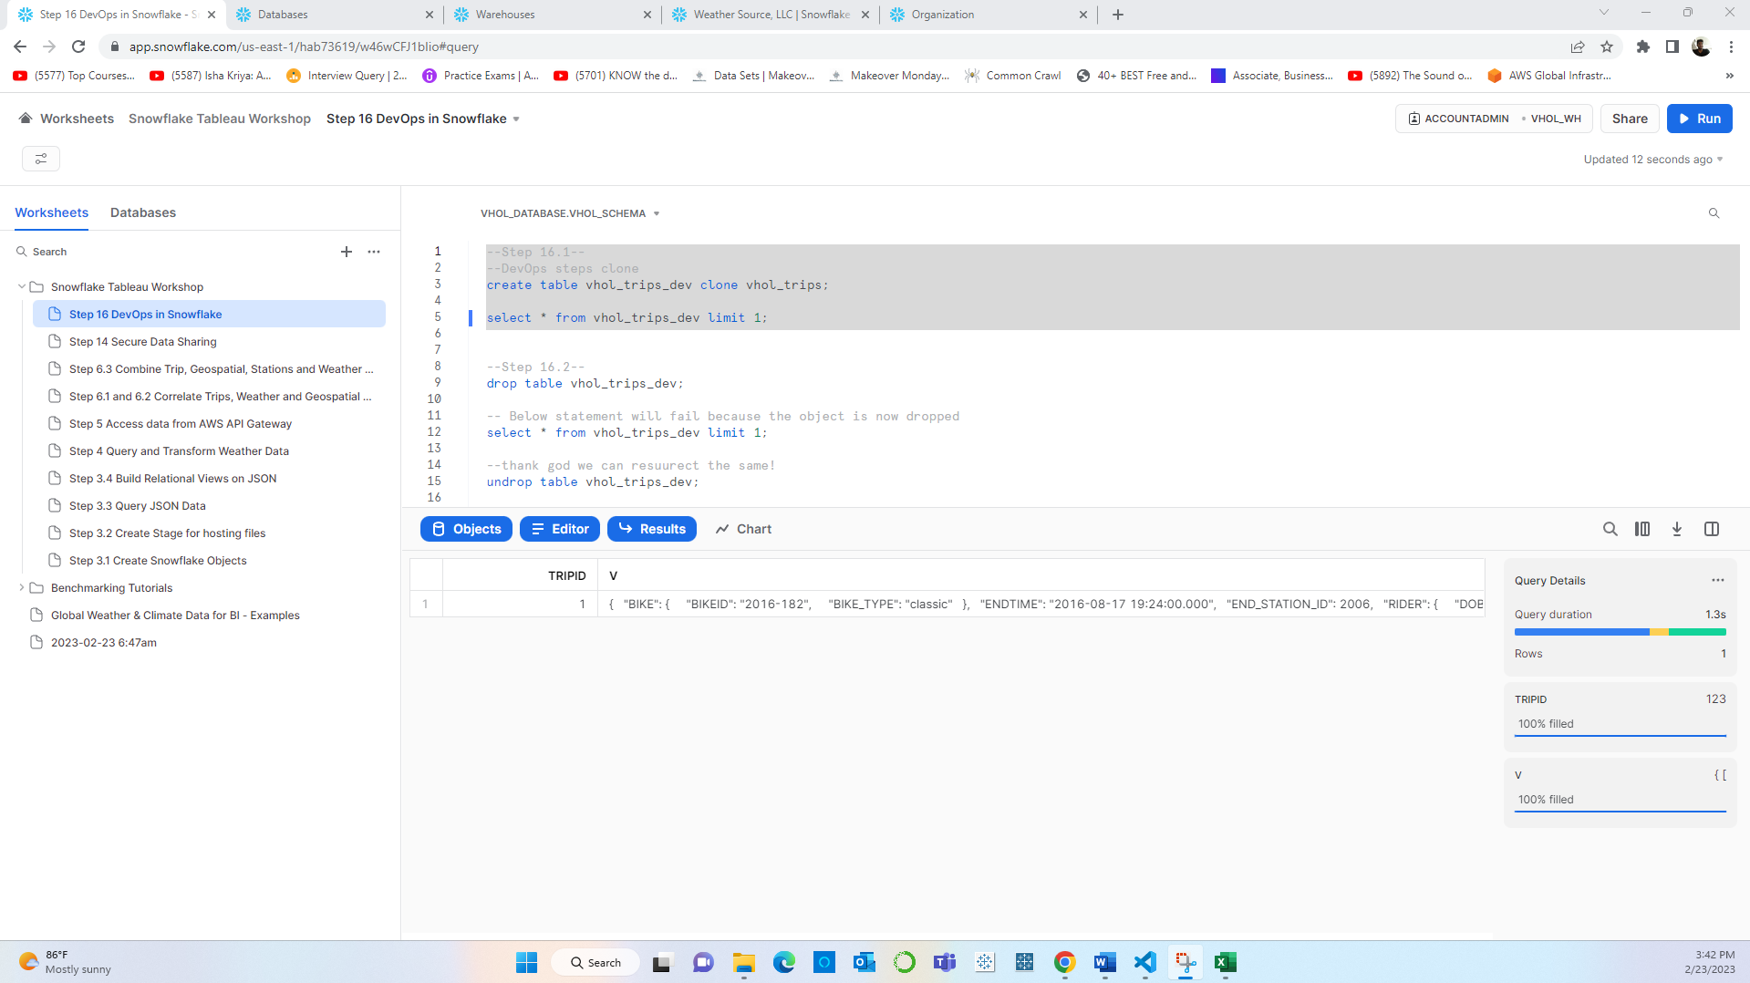

**Step 34:** Test table Created:

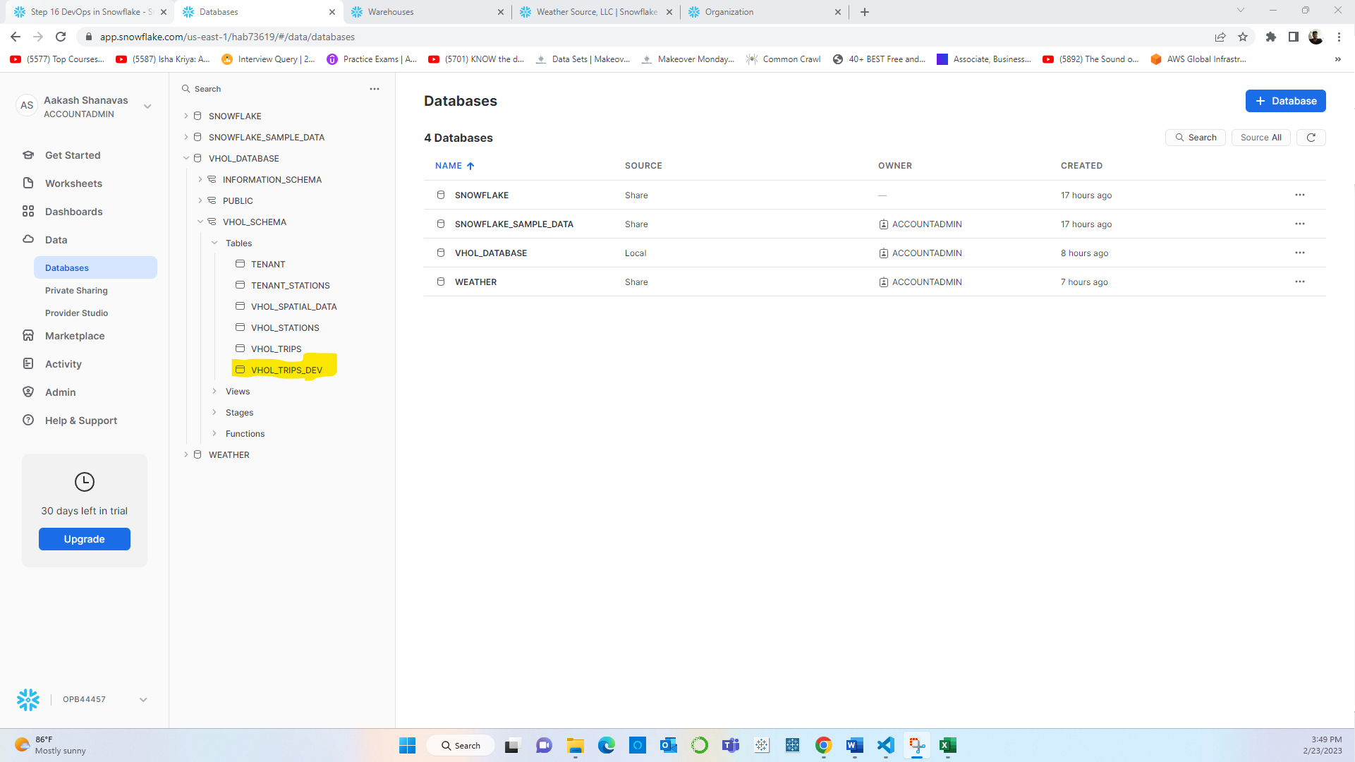

**Step 35:** Dropping the Table

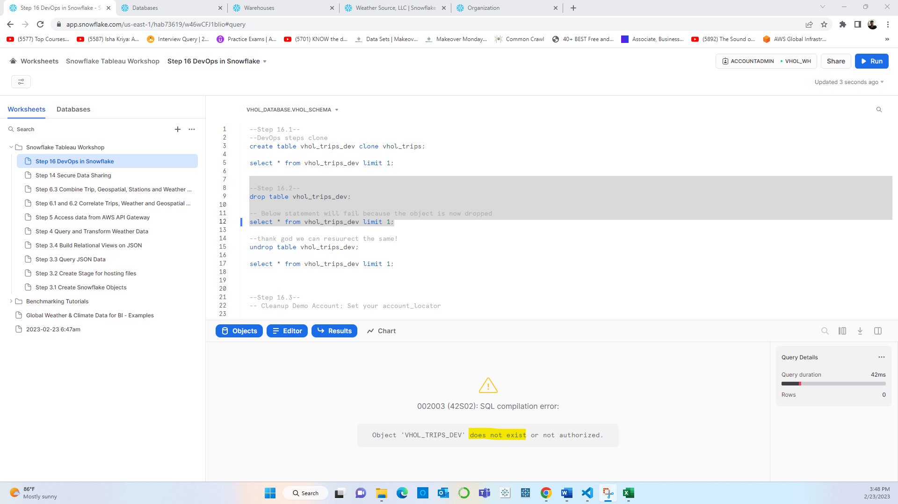

**Step 36:** Un dropping the table:

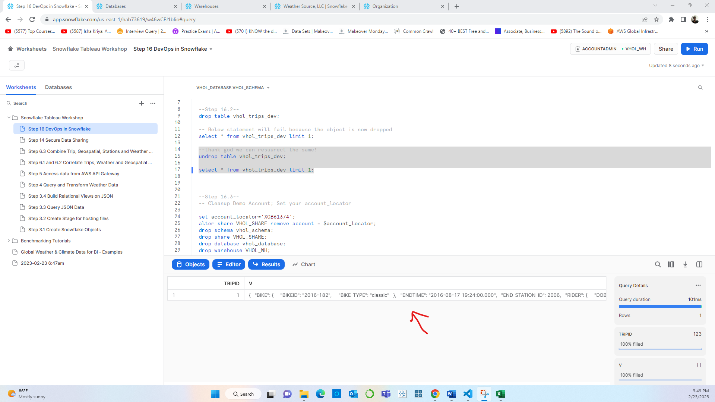

**Step 37:** Deleting the reader Account as well as deleting all the related Database, Schema, tables and Warehouse created for the demo account:

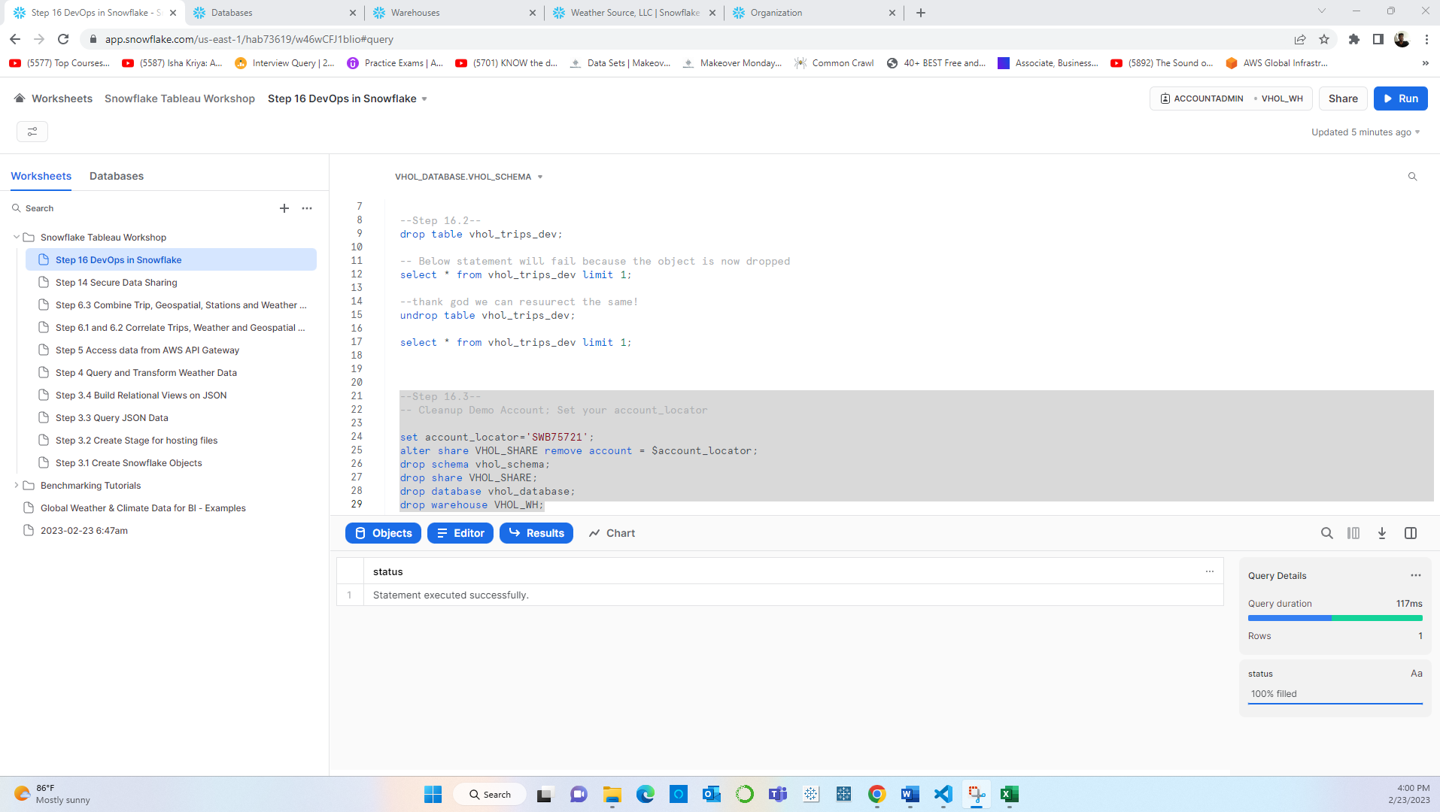

The entire lab work did not use up much credit. Around 4.25 $. And Snowflake provided 30-day free trial **with $400 worth of credits.**

